

DVTK Design Specification
DVTK Data Assembly

Version 1.0

2005-06-20
Table of Contents
1 Introduction 7
1.1 Purpose 7
1.2 Scope 7
1.3 Audience 7
1.4 Abbreviations and acronyms 7
1.5 References 7
1.6 History 7
2 The Global Overview of DVTK Data library 8
3 Detail design of DIMSE Data classes 9
3.1 Class Description of AttributeSet 9
3.1.1 Properties of AttributeSet class 9
3.1.2 Methods of AttributeSet class 9
3.2 Class Description of DataSet 10
3.2.1 Properties of DataSet class 10
3.2.2 Methods of DataSet class 10
3.3 Class Description of CommandSet 11
3.3.1 Properties of CommandSet class 11
3.3.2 Methods of CommandSet class 11
3.4 Class Description of SequenceItem 11
3.4.1 Methods of SequenceItem class 11
3.5 Class Description of Sequence 12
3.5.1 Properties of Sequence class 12
3.5.2 Methods of Sequence class 12
3.6 Class Description of SequenceOfItems 12
3.6.1 Properties of SequenceOfItems class 12
3.6.2 Methods of SequenceOfItems class 13
3.7 Class Description of DicomMessage 13
3.7.1 Properties of DicomMessage class 13
3.7.2 Methods of DicomMessage class 13
3.8 Class Description of Attribute 14
3.8.1 Properties of Attribute class 14
3.8.2 Methods of Attribute class 14
3.9 Class Description of Tag 15
3.9.1 Properties of Tag class 15
3.9.2 Methods of Tag class 15
4 Detail design of Value Representation classes 17
4.1 Class Description of DicomValueType 17
4.1.1 Methods of DicomValueType class 17
4.2 Derived Classes 17
4.2.1 Application Entity class 17
4.2.2 Age String class 18
4.2.3 Attribute Tag class 18
4.2.4 Code String class 18
4.2.5 Date class 18
4.2.6 Date Time class 18
4.2.7 Decimal String class 18
4.2.8 Unlimited Text class 19
4.2.9 Unsigned Short class 19
4.2.10 Unsigned Long class 19
4.2.11 Unique Identifier (UID) class 19
4.2.12 Time class 19
4.2.13 Short Text class 19
4.2.14 Signed Short class 20
4.2.15 Signed Long class 20
4.2.16 Short String class 20
4.2.17 Person Name class 20
4.2.18 Long Text class 20
4.2.19 Long String class 20
4.2.20 Integer String class 21
4.2.21 Floating Point Double class 21
4.2.22 Floating Point Single class 21
4.2.23 Unknown class 21
4.2.24 Other Word String class 21
4.2.25 Other Float String class 21
4.2.26 Other Byte String class 21
5 Detail design of DIMSE Validation Data classes 22
5.1 Class Description of ValidationObjectResult 22
5.1.1 Properties of ValidationObjectResult class 22
5.1.2 Methods of ValidationObjectResult class 22
5.2 Class Description of ValidationAttributeGroupResult 23
5.2.1 Properties of ValidationAttributeGroupResult class 23
5.2.2 Methods of ValidationAttributeGroupResult class 23
5.3 Class Description of ValidationAttributeResult 24
5.3.1 Properties of ValidationAttributeResult class 24
5.3.2 Methods of ValidationAttributeResult class 25
5.4 Class Description of ValidationValueResult 25
5.4.1 Properties of ValidationValueResult class 25
5.4.2 Methods of ValidationValueResult class 25
5.5 Class Description of ValidationMessage 26
5.5.1 Properties of ValidationMessage class 26
5.5.2 Methods of ValidationMessage class 26
5.6 Class Description of ValidationDirectoryRecordLink 26
5.6.1 Properties of ValidationDirectoryRecordLink class 27
5.6.2 Methods of ValidationDirectoryRecordLink class 28
5.7 Class Description of ValidationDirectoryRecordResult 28
5.7.1 Properties of ValidationDirectoryRecordResult class 28
5.7.2 Methods of ValidationDirectoryRecordResult class 29
6 Detail design of DUL Data classes 30
6.1 Class Description of PduItem 30
6.1.1 Properties of PduItem class 30
6.1.2 Methods of PduItem class 30
6.2 Class Description of ScpScuRoleSelection 30
6.2.1 Properties of ScpScuRoleSelection class 30
6.2.2 Methods of ScpScuRoleSelection class 31
6.3 Class Description of AsynchronousOperationsWindow 31
6.3.1 Properties of AsynchronousOperationsWindow class 31
6.3.2 Methods of AsynchronousOperationsWindow class 32
6.4 Class Description of ImplementationVersionName 32
6.4.1 Properties of ImplementationVersionName class 32
6.4.2 Methods of ImplementationVersionName class 32
6.5 Class Description of ImplementationClassUid 33
6.5.1 Properties of ImplementationClassUid class 33
6.5.2 Methods of ImplementationClassUid class 33
6.6 Class Description of MaximumLength 33
6.6.1 Properties of MaximumLength class 34
6.6.2 Methods of MaximumLength class 34
6.7 Class Description of UserInformation 34
6.7.1 Properties of UserInformation class 35
6.7.2 Methods of UserInformation class 36
6.8 Class Description of AbstractSyntax 36
6.8.1 Properties of AbstractSyntax class 36
6.8.2 Methods of AbstractSyntax class 37
6.9 Class Description of TransferSyntax 37
6.9.1 Properties of TransferSyntax class 37
6.9.2 Methods of TransferSyntax class 38
6.10 Class Description of RequestedPresentationContext 38
6.10.1 Properties of RequestedPresentationContext class 38
6.10.2 Methods of RequestedPresentationContext class 39
6.11 Class Description of AcceptedPresentationContext 39
6.11.1 Properties of AcceptedPresentationContext class 39
6.11.2 Methods of AcceptedPresentationContext class 40
6.12 Class Description of ApplicationContext 40
6.12.1 Properties of ApplicationContext class 40
6.12.2 Methods of ApplicationContext class 41
6.13 Class Description of DulMessage 41
6.13.1 Properties of DulMessage class 41
6.13.2 Methods of DulMessage class 41
6.14 Class Description of A_ASSOCIATE_RQ 41
6.14.1 Properties of A_ASSOCIATE_RQ class 42
6.14.2 Methods of A_ASSOCIATE_RQ class 43
6.15 Class Description of A_ASSOCIATE_AC 43
6.15.1 Properties of A_ASSOCIATE_AC class 43
6.15.2 Methods of A_ASSOCIATE_AC class 44
6.16 Class Description of A_ASSOCIATE_RJ 44
6.16.1 Properties of A_ASSOCIATE_RJ class 45
6.16.2 Methods of A_ASSOCIATE_RJ class 45
6.17 Class Description of A_ABORT 45
6.17.1 Properties of A_ABORT class 46
6.17.2 Methods of A_ABORT class 46
6.18 Class Description of A_RELEASE_RQ 46
6.18.1 Properties of A_RELEASE_RQ class 47
6.18.2 Methods of A_RELEASE_RQ class 47
6.19 Class Description of A_RELEASE_RP 47
6.19.1 Properties of A_RELEASE_RP class 47
6.19.2 Methods of A_RELEASE_RP class 48
6.20 Class Description of P_DATA_TF 48
6.20.1 Properties of P_DATA_TF class 48
6.20.2 Methods of P_DATA_TF class 48
7 Detail design of DUL Validation Data classes 49
7.1 Class Description of ValidationAcseParameter 49
7.1.1 Properties of ValidationAcseParameter class 49
7.1.2 Methods of ValidationAcseParameter class 49
7.2 Class Description of ValidationAbortRq 49
7.2.1 Properties of ValidationAbortRq class 50
7.2.2 Methods of ValidationAbortRq class 50
7.3 Class Description of ValidationAssociateRq 50
7.3.1 Properties of ValidationAssociateRq class 51
7.3.2 Methods of ValidationAssociateRq class 51
7.4 Class Description of ValidationAcsePresentationContextRequest 52
7.4.1 Properties of ValidationAcsePresentationContextRequest class 52
7.4.2 Methods of ValidationAcsePresentationContextRequest class 52
7.5 Class Description of ValidationAcseUserInformation 52
7.5.1 Properties of ValidationAcseUserInformation class 53
7.5.2 Methods of ValidationAcseUserInformation class 53
7.6 Class Description of ValidationAcseScpScuRoleSelect 54
7.6.1 Properties of ValidationAcseScpScuRoleSelect class 54
7.6.2 Methods of ValidationAcseScpScuRoleSelect class 54
7.7 Class Description of ValidationAcseAsynchronousOperationWindow 55
7.7.1 Properties of ValidationAcseAsynchronousOperationWindow class 55
7.7.2 Methods of ValidationAcseAsynchronousOperationWindow class 55
7.8 Class Description of ValidationAcseSopClassExtended 55
7.8.1 Properties of ValidationAcseSopClassExtended class 56
7.8.2 Methods of ValidationAcseSopClassExtended class 56
7.9 Class Description of ValidationAssociateAc 56
7.9.1 Properties of ValidationAssociateAc class 57
7.9.2 Methods of ValidationAssociateAc class 57
7.10 Class Description of ValidationAcsePresentationContextAccept 58
7.10.1 Properties of ValidationAcsePresentationContextAccept class 58
7.10.2 Methods of ValidationAcsePresentationContextAccept class 58
7.11 Class Description of ValidationAssociateRj 58
7.11.1 Properties of ValidationAssociateRj class 59
7.11.2 Methods of ValidationAssociateRj class 59
7.12 Class Description of ValidationReleaseRq 59
7.12.1 Methods of ValidationReleaseRq class 60
7.13 Class Description of ValidationReleaseRp 60
7.13.1 Methods of ValidationReleaseRp class 60
8 Detail design of Media Data classes 61
8.1 Class Description of DicomFile 61
8.1.1 Properties of DicomFile class 61
8.1.2 Methods of DicomFile class 61
8.2 Class Description of FileHead 62
8.2.1 Properties of FileHead class 62
8.2.2 Methods of FileHead class 62
9 Detail design of Result classes 63
9.1 Class Description of Result 63
9.1.1 Properties of Result class 63
9.2 Class Description of SubResultsLink 63
9.2.1 Properties of SubResultsLink class 63
9.2.2 Methods of SubResultsLink class 64
9.3 Class Description of Detail 64
9.3.1 Properties of Detail class 64
9.3.2 Methods of Detail class 65
9.4 Class Description of Counters 66
9.4.1 Properties of Counters class 66
9.4.2 Methods of Counters class 67
9.5 Class Description of Send 67
9.5.1 Properties of Send class 67
9.5.2 Methods of Send class 67
9.6 Class Description of Receive 67
9.6.1 Properties of Receive class 68
9.6.2 Methods of Receive class 68
9.7 Class Description of Import 68
9.7.1 Properties of Import class 68
9.7.2 Methods of Import class 68
9.8 Class Description of Display 69
9.8.1 Properties of Display class 69
9.8.2 Methods of Display class 69
9.9 Class Description of MediaWrite 69
9.9.1 Properties of MediaWrite class 70
9.9.2 Methods of MediaWrite class 70
9.10 Class Description of MediaRead 70
9.10.1 Properties of MediaRead class 70
9.10.2 Methods of MediaRead class 71
9.11 Class Description of DicomScriptCreate 71
9.11.1 Methods of DicomScriptCreate class 71
9.12 Class Description of DicomScriptSet 71
9.12.1 Methods of DicomScriptSet class 71
9.13 Class Description of DicomScriptDelete 71
9.13.1 Methods of DicomScriptDelete class 71
9.14 Class Description of DicomScriptCreateSetDeleteActionBase 72
9.14.1 Properties of DicomScriptCreateSetDeleteActionBase class 72
9.14.2 Methods of DicomScriptCreateSetDeleteActionBase class 72
9.15 Class Description of ByteDump 73
9.15.1 Properties of ByteDump class 73
9.15.2 Methods of ByteDump class 73
9.16 Class Description of DvtToXml 73
9.16.1 Methods of DvtToXml class 73

Introduction

Purpose
This document describes the global and detail design DVTK Data class library. This is a living document and changes in the design should be laid down in this document. This design document has been written down as a top-level interface specification. The entire interface specification is generated as code-documentation into a .CHM file, which can be referred from DVT installation.

Scope
DVTK Data library defines DICOM and DUL Messages classes and some DVTK specific data classes. These messages have been sent and received within DVTK sessions. Results are typically saved to XML results output files.

Audience
This document is intended for all the implementers in the DVT project. The reader is assumed to have basic DICOM knowledge.

Abbreviations and acronyms
Abbreviation / acronym | Description
AE | Application Entity
Definition File | File containing the DICOM SOP Class description(s).
DVT | DICOM Validation Tool.
DIMSE | DICOM Messaging Service Element(Communication Protocol).
DUL | DICOM Upper Layer (Communication Protocol).
IOD | Information Object Definition
VM | Value Multiplicity
VR | Value Representation
SUT | System Under Test

References
Reference | Title | Author/Publisher | Document number
VALIDATION |  | M. van Minderhout | XZS 980-000190.00
DESIGNSPEC |  | R. Busbridge  M. van Minderhout | XZS 980-000183.01
PATTERNS | Design Patterns | E. Gamma et al. | ISBN 0201633612
DCM | DICOM standard 2004 | NEMA | PS 3.0-2004
DEFINITION | Definition File Specification | M. van Minderhout | XZS 980-000123.00

History
Version | Date | Author | Description
0.1 | 20 June 2005 | Piyush Bhageriya  Manisha Singla | Initial version
1.0 | 29 June 2005 | Piyush Bhageriya  Manisha Singla | Update for OpenSource release

The Global Overview of DVTK Data library
The DVTK Data library provides data classes for:
- DUL messages
- DIMSE messages
- Validation output results

This layer is responsible for handling result data, generated during/after test processing. It handles the huge amount of data by using XML serializing .NET classes. The result is presented to the user in summary and detail format.
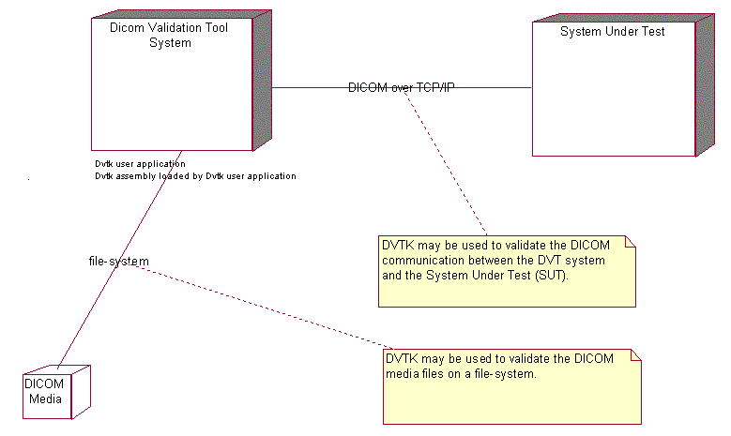
Figure 1 Global overview of DVTK Components

Detail design of DIMSE Data classes

Class Description of AttributeSet
The AttributeSet is the abstract base-class for DIMSE command-set and dataset classes. This class implements the logic for attribute indexing and settings for group length encoding and attribute value population.

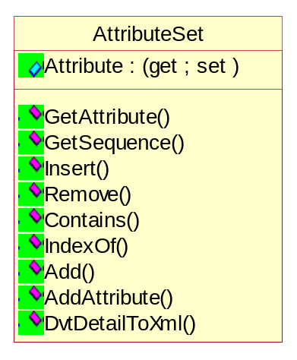
Figure 2 Class diagram of AttributeSet

Properties of AttributeSet class

Getting/Setting the attribute at the specified index
public new Attribute this[int index](get; set;)

Methods of AttributeSet class

Getting the first occurrence of attribute with attribute tag
public Attribute GetAttribute(GROUP_ELEMENT groupElement);

Getting the first occurrence of sequence with attribute tag
public Sequence GetSequence(GROUP_ELEMENT groupElement);

Managing an attribute in the AttributeSet list
public void Insert(int index, Attribute value);
public void Remove(Attribute value);
public bool Contains(Attribute value);
public int IndexOf(Attribute value);
public int Add(Attribute value);

Adding an attribute to the AttributeSet
public int AddAttribute(
GROUP_NUMBER groupNumber,
ELEMENT_NUMBER elementNumber,
VR vr,
params object[] list);
public int AddAttribute(
string groupNumberString,
string elementNumberString,
VR vr,
params object[] list);
public int AddAttribute(
GROUP_ELEMENT groupElement,
VR vr,
params object[] list);
public int AddAttribute(
string groupElementString,
VR vr,
params object[] list);

Serialize DVT Detail Data to Xml
public abstract bool DvtDetailToXml(StreamWriter streamWriter, int level);

Class Description of DataSet
This class represents the DataSet. DataSet is Exchanged information consisting of a structured set of Attributes. The value of each Attribute in a Data Set is expressed as a Data Element.
The value of each Attribute in a Data Set is expressed as a Data Element. A collection of Data Elements ordered by increasing Data Element Tag number that is an encoding of the values of Attributes of a real world object.

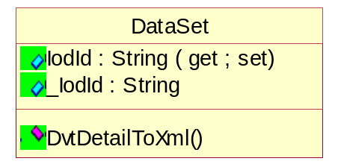
Figure 3 Class diagram of DataSet

Properties of DataSet class

Getting/Setting the IOD identifier
public System.String IodId(get; set;)
IOD identifier forms DVT application specific identifier that specifies the Information Object Definition to use during the validation of DICOM message exchange.
Each Information Object Class definition consists of a description of its purpose and the attributes, which define it.

Methods of DataSet class

Serialize DVT Detail Data to Xml
public override bool DvtDetailToXml(StreamWriter streamWriter, int level);

Class Description of CommandSet
This class represents the CommandSet. The Command Set is used to indicate the operations/notifications to be performed on or with the Data Set.
A Command Set is constructed of Command Elements. Command Elements contain the encoded values for each individual field of the
Command Set per the semantics specified in the DIMSE protocol (see Section 9.2 and 10.2).
Each Command Element is composed of an explicit Tag, a Value Length, and a Value Field.

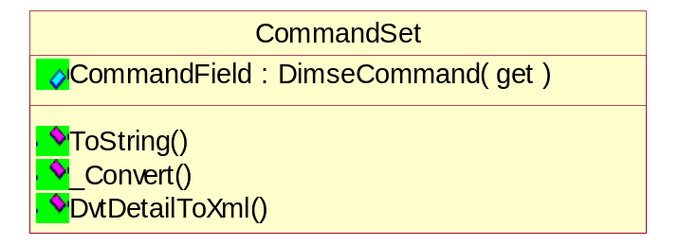
Figure 4 Class diagram of CommandSet

Properties of CommandSet class

Getting/Setting the type of DIMSE command
public DimseCommand CommandField(get; set;)
IOD identifier forms DVT application specific identifier that specifies the Information Object Definition to use during the validation of DICOM message exchange.
Each Information Object Class definition consists of a description of its purpose and the attributes, which define it.

Methods of CommandSet class

Getting a string representation of the command
private string ToString(DimseCommand dimseCommand);

Converting a integer command value to a command enum value
internal DimseCommand _Convert(System.Int16 underlyingValue);

Serialize DVT Detail Data to Xml
public override bool DvtDetailToXml(StreamWriter streamWriter, int level);

Class Description of SequenceItem
This class represents the SequenceItem. ITEM is a component of the Value of a Data Element that is of Value Representation Sequence of Items. An Item contains a Data Set.

Methods of SequenceItem class

Serialize DVT Detail Data to Xml
public override bool DvtDetailToXml(StreamWriter streamWriter, int level);

Class Description of Sequence
Sequence is a collection of SequenceItem. The collection is used by Attribute with DvtkData.Dimse.VR=DvtkData.Dimse.VR.SQ.

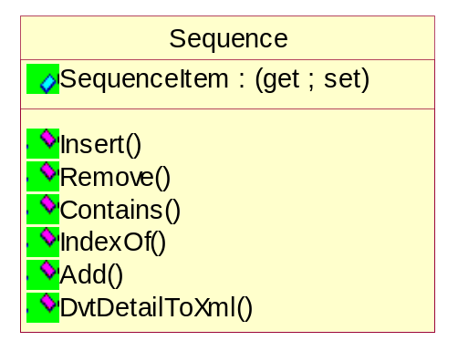
Figure 5 Class diagram of Sequence

Properties of Sequence class

Getting/Setting the attribute at the specified index
public new SequenceItem this[int index](get; set;)

Methods of Sequence class

Managing an Sequence in the AttributeSet list
public void Insert(int index, Attribute value);
public void Remove(Attribute value);
public bool Contains(Attribute value);
public int IndexOf(Attribute value);
public int Add(Attribute value);

Serialize DVT Detail Data to Xml
public bool DvtDetailToXml(StreamWriter streamWriter, int level);

Class Description of SequenceOfItems
Sequence of Items: Value is a Sequence of zero or more Items. The list of SequenceItem maintained by the SequenceOfItems attribute.

Properties of SequenceOfItems class

Getting/Setting the sequence
public Sequence Sequence(get; set;)

Methods of SequenceOfItems class

Serialize DVT Detail Data to Xml
public override bool DvtDetailToXml(StreamWriter streamWriter, int level);

Class Description of DicomMessage
This class represents the Message. Message is a data unit of the Message Exchange Protocol exchanged between two cooperating DICOM Applications.
A Message is composed of a Command Stream followed by an optional Data Stream.

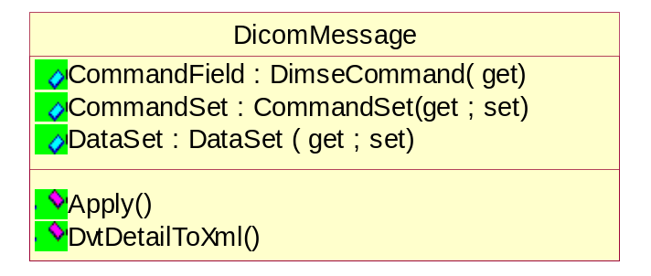
Figure 6 Class diagram of DICOMMessage

Properties of DicomMessage class

Getting/Setting the command field
public DimseCommand CommandField(get; set;)
The CommandField of the CommandSet linked to the DicomMessage.

Getting/Setting the command set
public CommandSet CommandSet(get; set;)

Getting/Setting the data set
public DataSet DataSet(get; set;)

Methods of DicomMessage class

Managing an Sequence in the AttributeSet list
public void Apply(CommandSet commandSet, DataSet dataSet);
public void Apply(CommandSet commandSet);

Serialize DVT Detail Data to Xml
public bool DvtDetailToXml(StreamWriter streamWriter, int level);

Class Description of Attribute
This class represents the Attribute. Attribute is a unit of information as defined by a single entry in the data dictionary.
An encoded Information Object Definition (IOD) Attribute that is composed of, at a minimum, three fields: a Data Element Tag, a Value Length, and a Value Field.
For some specific Transfer Syntaxes, a Data Element also contains a VR Field where the Value Representation of that Data Element is specified explicitly.

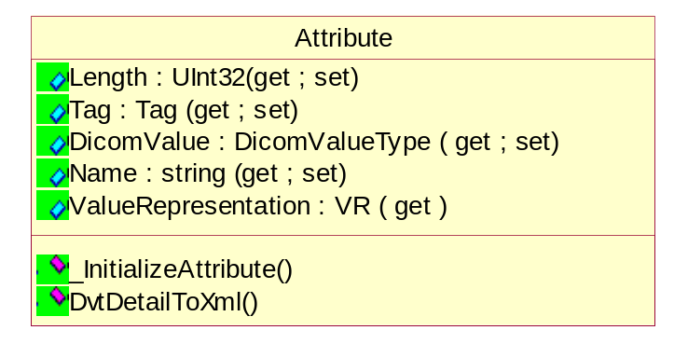
Figure 7 Class diagram of Attribute

Properties of Attribute class

Getting/Setting the attribute length
public System.UInt32 Length(get; set;)

Getting/Setting the attribute tag
public Tag Tag(get; set;)

Getting/Setting the attribute value
public DicomValueType DicomValue(get; set;)
For single-value attributes with value multiplicity equal to 1 this holds one value.
For multi-value attributes with value multiplicity more than 1 this holds an array of values.

Getting/Setting the attribute name
public string Name(get; set;)
This is a literal string identifying the attribute by name.

Getting/Setting the attribute VR
public VR ValueRepresentation(get; set;)

Methods of Attribute class

Initializing an attribute
private void _InitializeAttribute(
GROUP_NUMBER groupNumber,
ELEMENT_NUMBER elementNumber,
VR vr,
params object[] list)

Serialize DVT Detail Data to Xml
public bool DvtDetailToXml(StreamWriter streamWriter, int level);

Class Description of Tag
This class represents the Attribute Tag. Attribute tag is a unique identifier for a Data Element composed of an ordered pair of numbers (a Group Number followed by an Element Number).

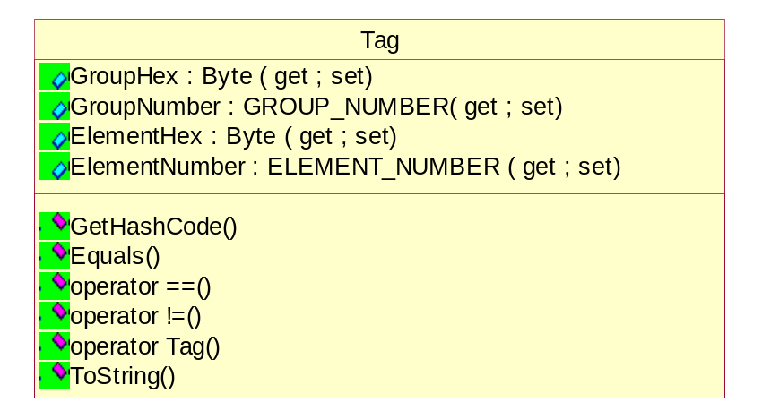
Figure 8 Class diagram of Tag

Properties of Tag class

Getting/Setting the hex value of Group
public System.Byte[] GroupHex(get; set;)

Getting/Setting the hex value of Element
public System.Byte[] ElementHex(get; set;)

Getting/Setting the Element number
public ELEMENT_NUMBER ElementNumber(get; set;)

Getting/Setting the Group number
public GROUP_NUMBER GroupNumber(get; set;)

Methods of Tag class

Getting the hash code for this instance
public override int GetHashCode();

Checking whether this instance is equal to a specified object
public override bool Equals(System.Object obj);

Operators
public static bool operator ==(Tag tag1, Tag tag2);
public static bool operator !=(Tag tag1, Tag tag2);

Obtaining the string representation of the tag
public override string ToString();

Detail design of Value Representation classes

Class Description of DicomValueType
DicomValueType is the abstract base-class for all sub-classes that implement specific value types.
The value types are mapped to their corresponding value representations.
VALUE FIELD: The field within a Data Element that contains the Value(s) of that Data Element.

Methods of DicomValueType class

Serialize DVT Detail Data to Xml
public abstract bool DvtDetailToXml(StreamWriter streamWriter, int level);

Derived Classes
All the derived classes represent DICOM Value Representation (VR) as explained in DICOM part-5. All the classes implements DvtDetailToXml() method.

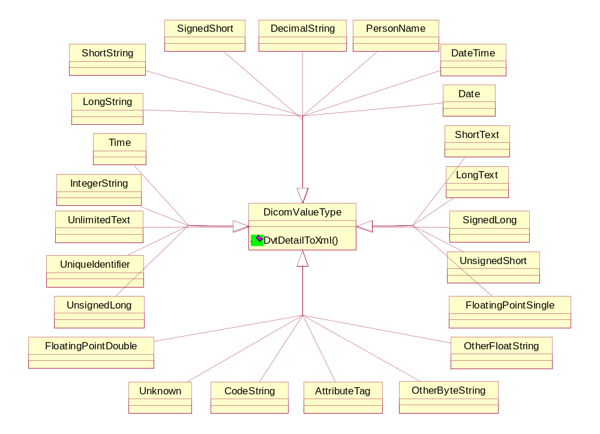
Figure 9 Relationship diagram of DICOM VR classes

Application Entity class
Application Entity is a string of characters with leading and trailing spaces (20H) being non-significant. The value made of 16 spaces, meaning, "no application name specified", shall not be used.

Age String class
This class represents the Age String class. A string of characters with one of the following formats -- nnnD, nnnW, nnnM, nnnY; where nnn shall contain the number of days for D,
weeks for W, months for M, or years for Y.
Example: “018M” would represent an age of 18 months.

Attribute Tag class
This class represents the Attribute Tag class. Ordered pair of 16-bit unsigned integers that is the value of a Data Element Tag.
Example: A Data Element Tag of (0018,00FF) would be encoded as a series of 4 bytes in a Little-Endian Transfer Syntax as 18H,00H,FFH,00H and in a Big-Endian Transfer Syntax as 00H,18H,00H,FFH.

Code String class
This class represents the Code String class. A string of characters with leading or trailing spaces (20H) being non-significant.

Date class
This class represents the Date class. A string of characters of the format yyyymmdd; where yyyy shall contain year, mm shall contain the month, and dd shall contain the
day. This conforms to the ANSI HISPP MSDS Date common data type.
Example: “19930822” would represent August 22, 1993.

Date Time class
This class represents the Date Time class. The Date Time data type indicates a concatenated date-time ASCII string in the format: YYYYMMDDHHMMSS.FFFFFF&amp;ZZZZ
The components of this string, from left to right, are YYYY = Year, MM = Month, DD = Day, HH = Hour, MM = Minute, SS = Second, FFFFFF = Fractional Second, &amp; = "+" or "-", and ZZZZ = Hours and Minutes of offset. ZZZZ is an optional suffix for plus/minus offset from Coordinated Universal Time.
A component that is omitted from the string is termed a null component. Trailing null components of Date Time are ignored. Nontrailing null components are prohibited, given that the optional suffix is not considered as a component.

Decimal String class
This class represents the Decimal String class. A string of characters representing either a fixed point number or a floating point number.
A fixed point number shall contain only the characters 0-9 with an optional leading "+" or "-" and an optional "." to mark the decimal
point. A floating-point number shall be conveyed as defined in ANSI X3.9, with an "E" or "e" to indicate the start of the exponent.
Decimal Strings may be padded with leading or trailing spaces. Embedded spaces are not allowed.

Unlimited Text class
This class represents the Unlimited Text class. A character string that may contain one or more paragraphs. It may contain the Graphic Character set and the Control Characters, CR, LF, FF, and ESC. It may be padded with trailing spaces, which may be ignored, but leading spaces are considered to be significant. Data Elements with this VR shall not be multi-valued and therefore character code 5CH (the BACKSLASH “\” in ISO-IR 6) may be used.

Unsigned Short class
This class represents the Unsigned Short class. Unsigned binary integer 16 bits long.

Unsigned Long class
This class represents the Unsigned Long class. Unsigned binary integer 32 bits long.

Unique Identifier (UID) class
This class represents the UID class. A character string containing a UID that is used to uniquely identify a wide variety of items. The UID is a series of numeric components separated by the period "." character. If a Value Field containing one or more UIDs is an odd number of bytes in length, the Value Field shall be padded with a single trailing NULL (00H) character to ensure that the Value Field is an even number of bytes in length.

Generating a Unique Identifier value
public static System.String GenerateUidValue();

Time class
This class represents the Time class. A string of characters of the format hhmmss.frac; where hh contains hours (range "00" - "23"), mm contains minutes (range "00" - "59"), ss contains seconds (range "00" - "59"), and frac contains a fractional part of a second as small as 1 millionth of a second (range “000000” - “999999”). A 24 hour clock is assumed. Midnight can be represented by only “0000“ since “2400“ would violate the hour range. The string may be padded with trailing spaces. Leading and embedded spaces are not allowed. One or more of the components mm, ss, or frac may be unspecified as long as every component to the right of an unspecified component is also unspecified. If frac is unspecified the preceding “.” may not be included. Frac shall be held to six decimal places or less to ensure its format conforms to the ANSI HISPP MSDS Time common data type.

Adding value to the attribute
public void AddValue(System.DateTime value, Format format);

Short Text class
This class represents the Short Text class. A character string that may contain one or more paragraphs. It may contain the Graphic Character set and the Control Characters, CR, LF, FF, and ESC. It may be padded with trailing spaces, which may be ignored, but leading spaces are considered to be significant. Data Elements with this VR shall not be multi-valued and therefore character code 5CH (the BACKSLASH “\” in ISO-IR 6) may be used.

Adding value to the attribute
public string Value(get; set;)

Signed Short class
This class represents the Signed Short class. Signed binary integer 16 bits long in 2's complement form. Represents an integer n in the range -2^15 &lt;= n &lt;= (2^15 - 1)

Signed Long class
This class represents the Signed Short class. Signed binary integer 32 bits long in 2's complement form. It represents an integer, n, in the range:
-2^31 &lt;= n &lt;= (2^31 - 1)

Short String class
This class represents the Short String class. A character string that may be padded with leading and/or trailing spaces. The character code 05CH (the BACKSLASH “\” in ISO-IR 6) shall not be present, as it is used as the delimiter between values for multiple data elements. The string shall not have Control Characters except ESC.

Person Name class
This class represents the Person Name class. A character string encoded using a 5 component convention. The character code 5CH (the BACKSLASH “\” in ISO-IR 6) shall not be present, as it is used as the delimiter between values in multiple valued data elements. The string may be padded with trailing spaces. The five components in their order of occurrence are: family name complex, given name complex, middle name, name prefix, name suffix. Any of the five components may be an empty string. The component delimiter shall be the caret “^” character (5EH). Delimiters are required for interior null components. Trailing null components and
their delimiters may be omitted. Multiple entries are permitted in each component and are encoded as natural text strings, in the format preferred by the named person. This conforms to the ANSI HISPP MSDS Person Name common data type.
This group of five components is referred to as a Person Name component group.

Long Text class
This class represents the Long Text class. A character string that may contain one or more paragraphs. It may contain the Graphic Character set and the Control Characters, CR, LF, FF, and ESC. It may be padded with trailing spaces, which may be ignored, but leading spaces are considered to be significant. Data Elements with this VR shall not be multi-valued and therefore character code 5CH (the BACKSLASH “\” in ISO-IR 6) may be used.

Long String class
This class represents the Long String class. A character string that may be padded with leading and/or trailing spaces. The character code 5CH (the BACKSLASH “\” in ISO-IR 6) shall not be present, as it is used as the delimiter between values in multiple valued data elements. The string shall not have Control Characters except for ESC.

Integer String class
This class represents the Integer String class. A string of characters representing an Integer in base-10 (decimal), shall contain only the characters 0 - 9, with an optional leading "+" or "-". It may be padded with leading and/or trailing spaces. Embedded spaces are not allowed.
The integer, n, represented shall be in the range:
-2^31 &lt;= n &lt;= (2^31 - 1)

Floating Point Double class
This class represents the Floating Point Double class. Double precision binary floating-point number represented in IEEE 754:1985 64-bit Floating Point Number Format.

Floating Point Single class
This class represents the Floating Point Single class. Single precision binary floating-point number represented in IEEE 754:1985 32-bit Floating Point Number Format.

Unknown class
This class represents the Unknown class. A string of bytes where the encoding of the contents is unknown.

Other Word String class
This class represents the Other Word String class. A string of 16-bit words where the encoding of the contents is specified by the negotiated Transfer Syntax. OW is a VR which requires byte swapping within each word when changing between Little Endian and Big Endian byte ordering.

Other Float String class
This class represents the Other Float String class. A string of 32-bit IEEE 754:1985 floating point words. OF is a VR which requires byte swapping within each 32-bit word when changing between Little Endian and Big Endian byte ordering.

Other Byte String class
This class represents the Other Byte String class. A string of bytes where the encoding of the contents is specified by the negotiated Transfer Syntax. OB is a VR which is insensitive to Little/Big Endian byte ordering. The string of bytes shall be padded with a single trailing NULL byte value (00H) when necessary to achieve even length.

Detail design of DIMSE Validation Data classes

Class Description of ValidationObjectResult
This class provides validation information about information object. An Information Object may be validated against reference and/or definition objects.

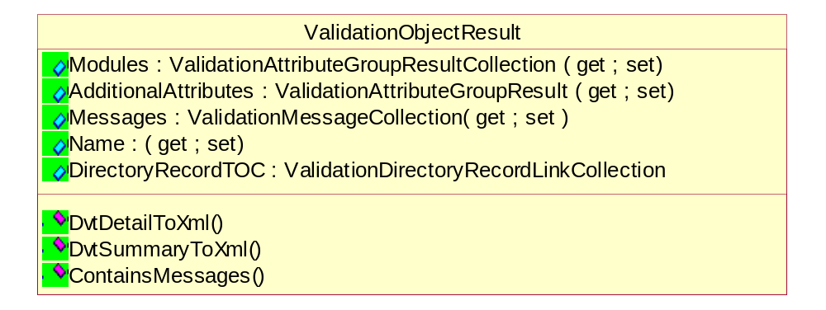
Figure 10 Class diagram of ValidationObjectResult

Properties of ValidationObjectResult class

Getting/Setting the validation information about attributes from modules
public ValidationAttributeGroupResultCollection Modules(get; set;)

Getting/Setting the validation information about attributes from addl attributes
public ValidationAttributeGroupResult AdditionalAttributes(get; set;)

Getting/Setting the validation messages
public ValidationMessageCollection Messages(get; set;)

Getting/Setting the identifying name
public string Name(get; set;)

Getting/Setting the table of contents for directory records
public ValidationDirectoryRecordLinkCollection DirectoryRecordTOC(get; set;)

Methods of ValidationObjectResult class

Checking if this contains any validation messages
private bool ContainsMessages();

Serialize DVT Detail Data to Xml
public bool DvtDetailToXml(StreamWriter streamWriter, int level);

Serialize DVT Summary Data to Xml
public bool DvtSummaryToXml(StreamWriter streamWriter, int level);

Class Description of ValidationAttributeGroupResult
This class provides validation information about the set of DICOM attributes.

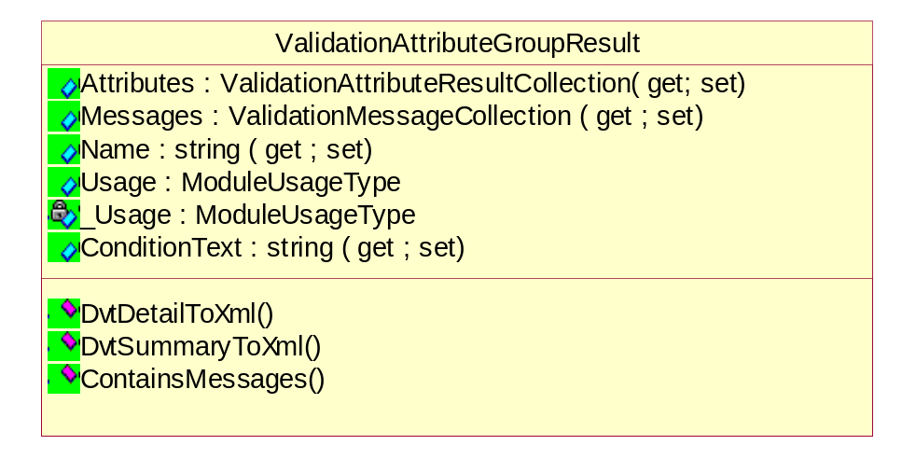
Figure 11 Class diagram of ValidationAttributeGroupResult

Properties of ValidationAttributeGroupResult class

Getting/Setting the validation information about attributes from modules
public ValidationAttributeResultCollection Attributes(get; set;)

Getting/Setting the validation messages
public ValidationMessageCollection Messages(get; set;)

Getting/Setting the identifying name
public string Name(get; set;)

Getting/Setting the module usage
public ModuleUsageType Usage(get; set;)

Getting/Setting the a literal text specifying a condition
public string ConditionText(get; set;)

Methods of ValidationAttributeGroupResult class

Checking if this contains any validation messages
private bool ContainsMessages();

Serialize DVT Detail Data to Xml
public bool DvtDetailToXml(StreamWriter streamWriter, int level);

Serialize DVT Summary Data to Xml
public bool DvtSummaryToXml(StreamWriter streamWriter, int level);

Class Description of ValidationAttributeResult
This class provides validation information about DICOM attribute.

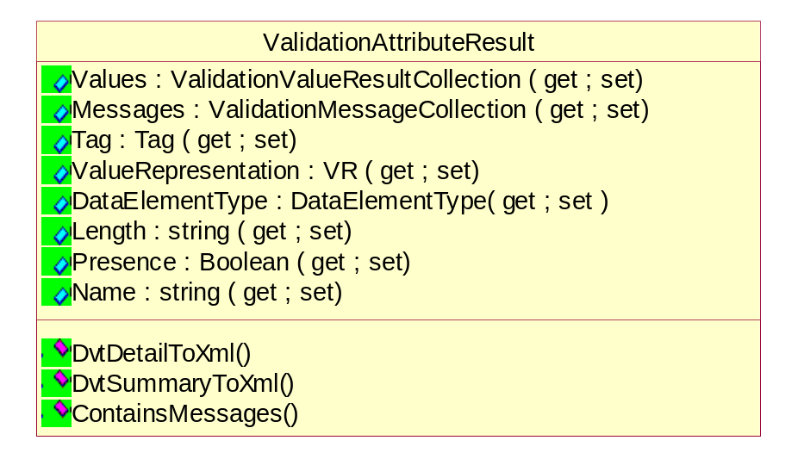
Figure 12 Class diagram of ValidationAttributeResult

Properties of ValidationAttributeResult class

Getting/Setting the collection attributes values
public ValidationValueResultCollection Values(get; set;)

Getting/Setting the validation messages
public ValidationMessageCollection Messages(get; set;)

Getting/Setting the attribute tag
public DvtkData.Dimse.Tag Tag(get; set;)

Getting/Setting the attribute VR
public DvtkData.Dimse.VR ValueRepresentation(get; set;)

Getting/Setting the attribute type
public DataElementType DataElementType(get; set;)

Getting/Setting the attribute length
public System.UInt32 Length(get; set;)

Getting/Setting the presence of attribute in DICOM message
public System.Boolean Presence(get; set;)

Getting/Setting the attribute name
public string Name(get; set;)

Methods of ValidationAttributeResult class

Checking if this contains any validation messages
private bool ContainsMessages();

Serialize DVT Detail Data to Xml
public bool DvtDetailToXml(StreamWriter streamWriter, int level);

Serialize DVT Summary Data to Xml
public bool DvtSummaryToXml(StreamWriter streamWriter, int level);

Class Description of ValidationValueResult
This class provides validation information about DICOM value.

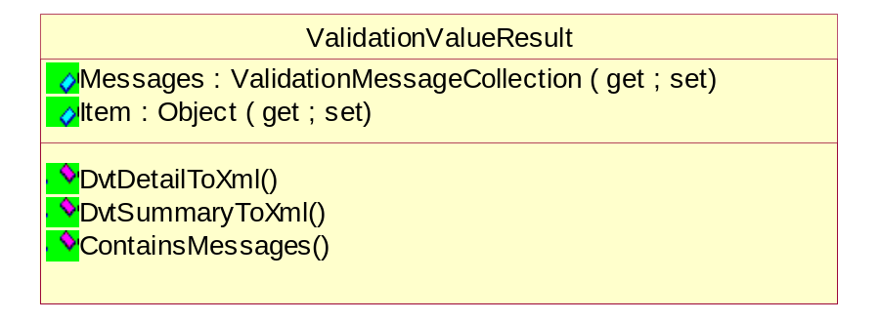
Figure 13 Class diagram of ValidationValueResult

Properties of ValidationValueResult class

Getting/Setting the information about validation item
public object Item(get; set;)

Getting/Setting the validation messages
public ValidationMessageCollection Messages(get; set;)

Methods of ValidationValueResult class

Checking if this contains any validation messages
private bool ContainsMessages();

Serialize DVT Detail Data to Xml
public bool DvtDetailToXml(StreamWriter streamWriter, int level);

Serialize DVT Summary Data to Xml
public bool DvtSummaryToXml(StreamWriter streamWriter, int level);

Class Description of ValidationMessage
This class represents validation message. The basic output of the validation against a set of rules.

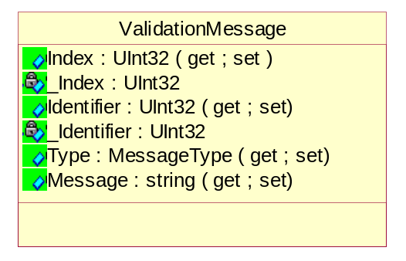
Figure 14 Class diagram of ValidationMessage

Properties of ValidationMessage class

Getting/Setting the unique index number of the message
public System.UInt32 Index(get; set;)

Getting/Setting the validation rule identifier
public System.UInt32 Identifier(get; set;)

Getting/Setting the message type
public MessageType Type(get; set;)

Getting/Setting the message
public string Message(get; set;)

Methods of ValidationMessage class

Serialize DVT Detail Data to Xml
public bool DvtDetailToXml(StreamWriter streamWriter, int level);

Class Description of ValidationDirectoryRecordLink
This class represents link to the validation information of a directory record.
Validation of a DICOM media file can result large quantities of validation results output. Therefore, the validation information for the individual DICOM directory records has be split-off into separate validation results output files.
This link describes the link to the split-off validation results of the directory records.

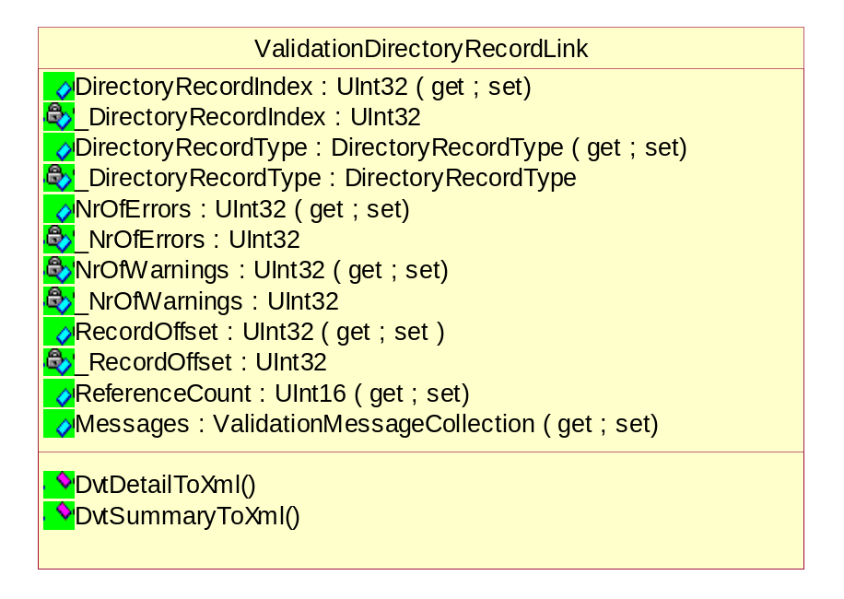
Figure 15 Class diagram of ValidationDirectoryRecordLink

Properties of ValidationDirectoryRecordLink class

Getting/Setting the directory record index
public System.UInt32 DirectoryRecordIndex(get; set;)

Getting/Setting the directory record type
public DirectoryRecordType DirectoryRecordType(get; set;)

Getting/Setting the nr of errors for the directory record
public System.UInt32 NrOfErrors(get; set;)

Getting/Setting the nr of errors for the directory record
public System.UInt32 NrOfWarnings(get; set;)

Getting/Setting the directory record offset
public System.UInt32 RecordOffset(get; set;)

Getting/Setting the nr of times directory record referenced
public System.UInt16 ReferenceCount(get; set;)

Getting/Setting the message
public ValidationMessageCollection Messages(get; set;)

Methods of ValidationDirectoryRecordLink class

Serialize DVT Detail Data to Xml
public bool DvtDetailToXml(StreamWriter streamWriter, int level);

Serialize DVT Summary Data to Xml
public bool DvtSummaryToXml(StreamWriter streamWriter, int level);

Class Description of ValidationDirectoryRecordResult
This class provides validation information about directory records. Directory records are part of DICOM media.

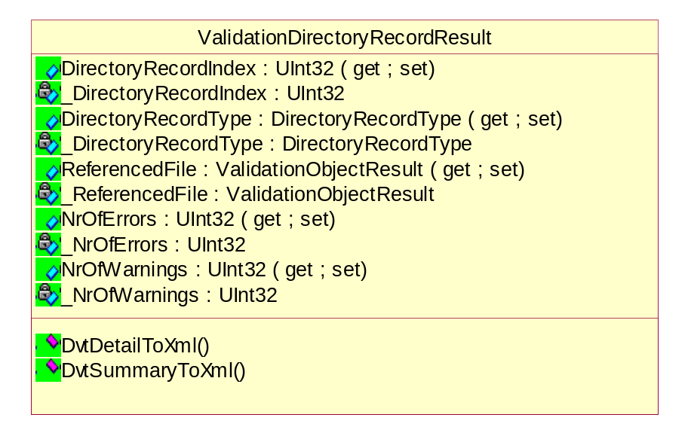
Figure 16 Class diagram of ValidationDirectoryRecordResult

Properties of ValidationDirectoryRecordResult class

Getting/Setting the directory record index
public System.UInt32 DirectoryRecordIndex(get; set;)

Getting/Setting the directory record type
public DirectoryRecordType DirectoryRecordType(get; set;)

Getting/Setting the nr of errors for the directory record
public System.UInt32 NrOfErrors(get; set;)

Getting/Setting the nr of errors for the directory record
public System.UInt32 NrOfWarnings(get; set;)

Getting/Setting the directory record offset
public ValidationObjectResult ReferencedFile(get; set;)

Methods of ValidationDirectoryRecordResult class

Serialize DVT Detail Data to Xml
public bool DvtDetailToXml(StreamWriter streamWriter, int level);

Serialize DVT Summary Data to Xml
public bool DvtSummaryToXml(StreamWriter streamWriter, int level);

Detail design of DUL Data classes

Class Description of PduItem
This is the abstract class and represents PDU item.

Properties of PduItem class

Getting the PDU Item type
public virtual PduItemType PduItemType(get; set;)

Methods of PduItem class

Serialize DVT Detail Data to Xml
public abstract bool DvtDetailToXml(StreamWriter streamWriter, int level);

Class Description of ScpScuRoleSelection
This class provides the SCP/SCU role selection. The SCP/SCU role selection negotiation allows peer AEs to negotiate the roles in which they will serve for each SOP Class or Meta SOP Class supported on the Association. This negotiation is optional.

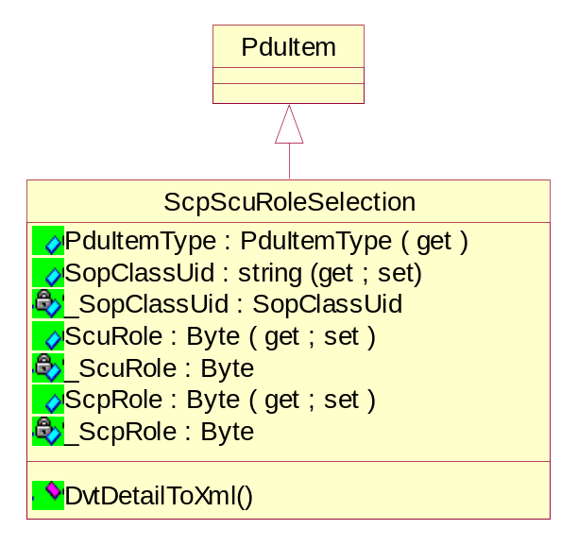
Figure 17 Class diagram of PDUItem

Properties of ScpScuRoleSelection class

Getting the PDU item type as SCP_SCU_ROLE_SELECTION
public override PduItemType PduItemType(get;)

Getting/Setting the SOP clad UID
public string SopClassUid(get; set;)

Getting/Setting the SCU role
public System.Byte ScuRole(get; set;)

Getting/Setting the SCP role
public System.Byte ScpRole(get; set;)

Methods of ScpScuRoleSelection class

Serialize DVT Detail Data to Xml
public bool DvtDetailToXml(StreamWriter streamWriter, int level);

Class Description of AsynchronousOperationsWindow
This class provides the Asynchronous Operations Window. The Asynchronous Operations Window is used to negotiate the maximum number of outstanding operation or sub-operation requests (i.e. command requests) for each direction.
The synchronous operations mode is the default mode and shall be support by all DICOM AEs. This negotiation is optional.

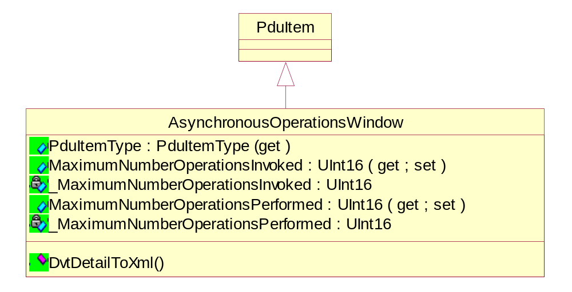
Figure 18 Class diagram of AsynchronousOperationsWindow

Properties of AsynchronousOperationsWindow class

Getting the PDU item type as ASYNCHRONOUS_OPERATIONS_WINDOW
public override PduItemType PduItemType(get;)

Getting/Setting the operations invoked
public System.UInt16 MaximumNumberOperationsInvoked(get; set;)

Getting/Setting the operations performed
public System.UInt16 MaximumNumberOperationsPerformed(get; set;)

Methods of AsynchronousOperationsWindow class

Serialize DVT Detail Data to Xml
public bool DvtDetailToXml(StreamWriter streamWriter, int level);

Class Description of ImplementationVersionName
This class provides the Implementation Version Name. The implementation identification notification allows implementations of communicating AEs to identify each other at Association establishment time.
It is intended to provide respective (each network node knows the other's implementation identity) and non-ambiguous identification in the event of communication problems encountered between two nodes.
This negotiation is required.

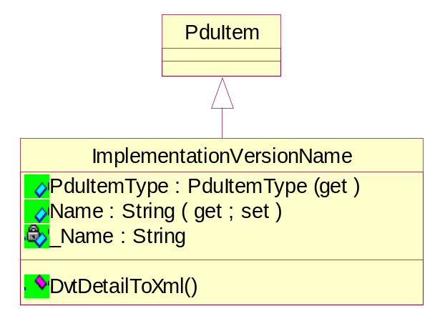
Figure 19 Class diagram of ImplementationVersionName

Properties of ImplementationVersionName class

Getting the PDU item type as IMPLEMENTATION_VERSION_NAME
public override PduItemType PduItemType(get;)

Getting/Setting the Implementation Version Name
public string Name(get; set;)

Methods of ImplementationVersionName class

Serialize DVT Detail Data to Xml
public bool DvtDetailToXml(StreamWriter streamWriter, int level);

Class Description of ImplementationClassUid
This class provides the Implementation Class UID. The implementation identification notification allows implementations of communicating AEs to identify each other at Association establishment time.
This negotiation is required.

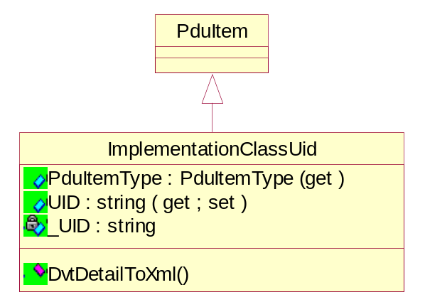
Figure 20 Class diagram of ImplementationClassUid
Only one Implementation Class UID Sub-Item shall be present in the User Data Item of the A-ASSOCIATE-RQ.

Properties of ImplementationClassUid class

Getting the PDU item type as IMPLEMENTATION_UID
public override PduItemType PduItemType(get;)

Getting/Setting the Implementation Class UID
public string UID(get; set;)

Methods of ImplementationClassUid class

Serialize DVT Detail Data to Xml
public bool DvtDetailToXml(StreamWriter streamWriter, int level);

Class Description of MaximumLength
This class provides the Maximum length. The Maximum Length notification allows communicating AEs to limit the size of the data for each P-DATA indication.
Each DICOM AE defines the maximum PDU size it can receive on this Association. Therefore, different maximum lengths can be specified for each direction of data flow on an Association.

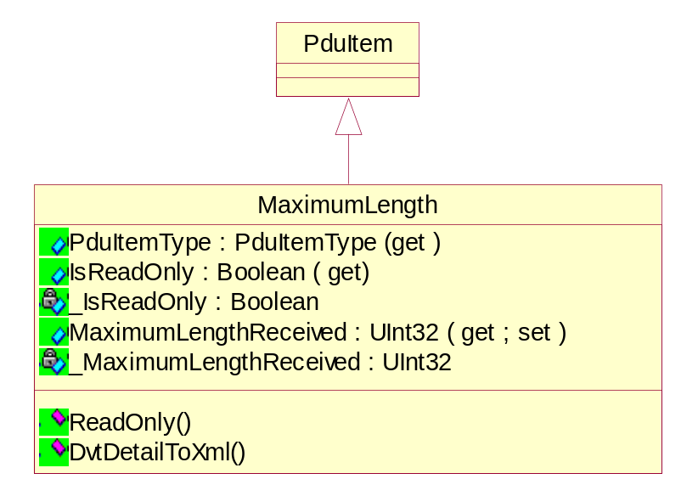
Figure 21 Class diagram of MaximumLength

Properties of MaximumLength class

Getting the PDU item type as MAXIMUM_LENGTH
public override PduItemType PduItemType(get;)

Getting the maximum length as read only
public System.Boolean IsReadOnly(get;)

Getting/Setting the maximum length received
public System.UInt32 MaximumLengthReceived(get; set;)

Methods of MaximumLength class

Getting the maximum length as read only
private static MaximumLength ReadOnly(MaximumLength maximumLength);

Serialize DVT Detail Data to Xml
public bool DvtDetailToXml(StreamWriter streamWriter, int level);

Class Description of UserInformation
This class provides the User Information. Peer DICOM AEs negotiate, at Association establishment, a number of features related to the Dimse protocol by using the ACSE User Information Item of the A-ASSOCIATE request.

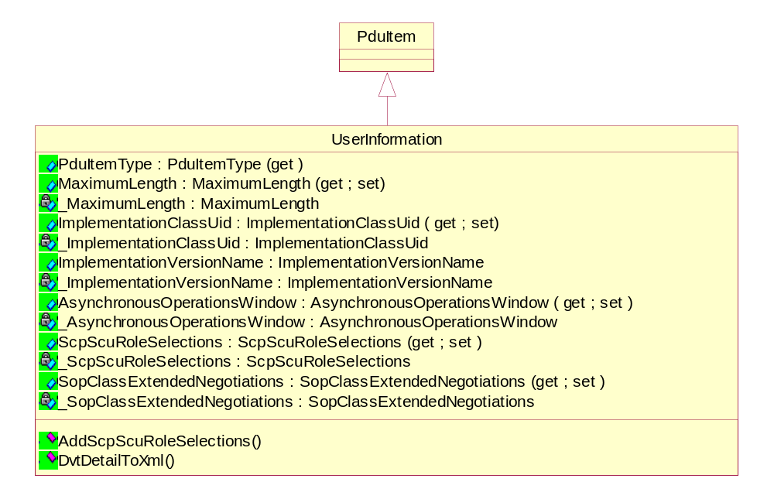
Figure 22 Class diagram of UserInformation

Properties of UserInformation class

Getting the PDU item type as USER_INFORMATION
public override PduItemType PduItemType(get;)

Getting/Setting the maximum length received
public MaximumLength MaximumLengthReceived(get; set;)

Getting/Setting the implementation class UID
public ImplementationClassUid ImplementationClassUid(get; set;)

Getting/Setting the implementation version name
public ImplementationVersionName ImplementationVersionName(get; set;)

Getting/Setting the Async operation window
public AsynchronousOperationsWindow AsynchronousOperationsWindow(get; set;)

Getting/Setting the SCP/SCU role selections
public ScpScuRoleSelectionList ScpScuRoleSelections(get; set;)

Getting/Setting the extended SOP class negotiations
public SopClassExtendedNegotiationList SopClassExtendedNegotiations(get; set;)

Methods of UserInformation class

Adding the SCP/SCU role selection array to the list
public void AddScpScuRoleSelections(
params ScpScuRoleSelection[] scpScuRoleSelections);

Adding the extended SOP class negotiations array to the list
public void AddSopClassExtendedNegotiations(
params SopClassExtendedNegotiation[] sopClassExtendedNegotiations);

Serialize DVT Detail Data to Xml
public bool DvtDetailToXml(StreamWriter streamWriter, int level);

Class Description of AbstractSyntax
This class provides the Abstract Syntax. DICOM AEs use the Abstract Syntax Name to identify and negotiate which SOP Classes and related options are supported on a specific Association.
Each Abstract Syntax shall be identified by an abstract Syntax Name in the form of a UID.
Abstract Syntax Names shall be defined in the Service Class Definitions specified in PS 3.4.
Each Abstract Syntax Name defined shall have a value of either:
- Service-Object Pair Class UID
- Meta Service-Object Pair Group UID

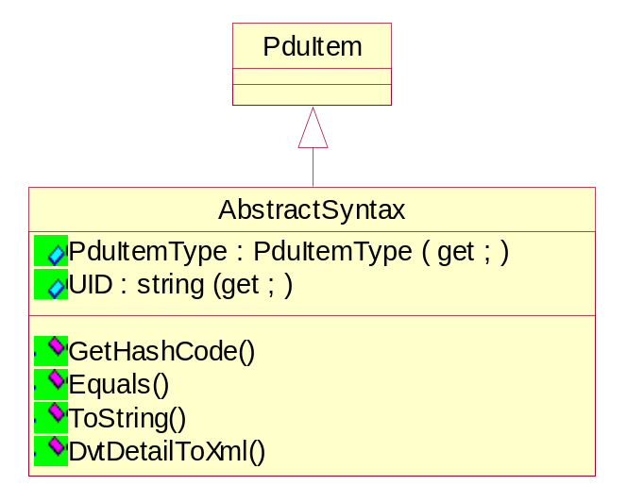
Figure 23 Class diagram of AbstractSyntax

Properties of AbstractSyntax class

Getting the PDU item type as ABSTRACT_SYNTAX
public override PduItemType PduItemType(get;)

Getting the abstract syntax UID
public string UID(get;)

Methods of AbstractSyntax class

Getting the hash code for this instance
public override int GetHashCode();

Getting the equlity for this instance with specified object
public override bool Equals(System.Object obj);

Getting the string representation of abstract syntax
public override string ToString();

Serialize DVT Detail Data to Xml
public bool DvtDetailToXml(StreamWriter streamWriter, int level);

Class Description of TransferSyntax
This class provides the Transfer Syntax. Transfer Syntax is an attribute of a Presentation Context, one or more of which are negotiated at the establishment of an Association between DICOM Application Entities.
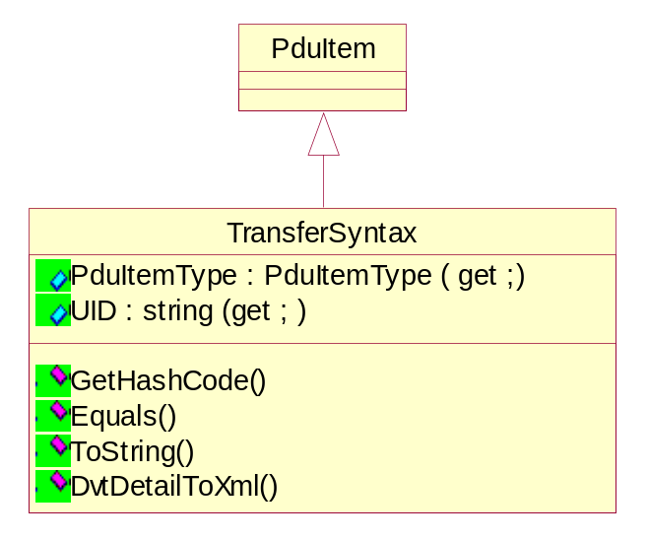
Figure 24 Class diagram of TransferSyntax

Properties of TransferSyntax class

Getting the PDU item type as TRANSFER_SYNTAX
public override PduItemType PduItemType(get;)

Getting the transfer syntax UID
public string UID(get;)

Methods of TransferSyntax class

Getting the hash code for this instance
public override int GetHashCode();

Getting the equlity for this instance with specified object
public override bool Equals(System.Object obj);

Getting the string representation of transfer syntax
public override string ToString();

Serialize DVT Detail Data to Xml
public bool DvtDetailToXml(StreamWriter streamWriter, int level);

Class Description of RequestedPresentationContext
This class provides the Requested Presentation Context. This class specifies RequestedPresentationContext PDU item.
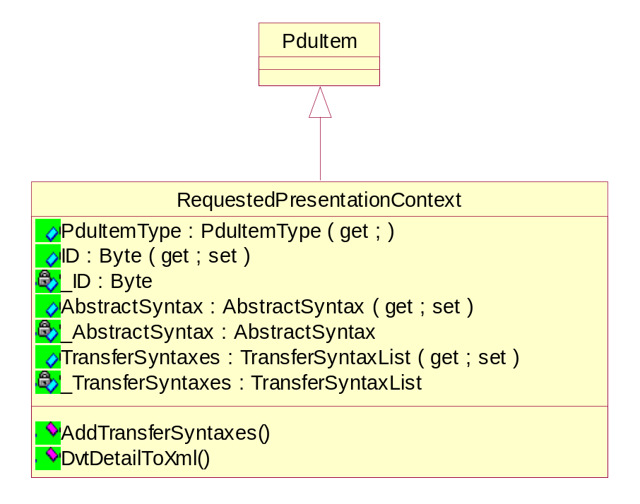
Figure 25 Class diagram of RequestedPresentationContext

Properties of RequestedPresentationContext class

Getting the PDU item type as RQ_PRESENTATION_CONTEXT
public override PduItemType PduItemType(get;)

Getting the Requested Presentation Context ID
public System.Byte ID(get; set;)

Getting the abstract syntax
public AbstractSyntax AbstractSyntax(get; set;)

Getting the list of transfer syntaxes
public TransferSyntaxList TransferSyntaxes(get; set)

Methods of RequestedPresentationContext class

Getting the hash code for this instance
public override int GetHashCode();

Serialize DVT Detail Data to Xml
public bool DvtDetailToXml(StreamWriter streamWriter, int level);

Class Description of AcceptedPresentationContext
This class provides the Accepted Presentation Context. Transfer Syntax is an attribute of a Presentation Context, one or more of which are negotiated at the establishment of an Association between DICOM Application Entities.
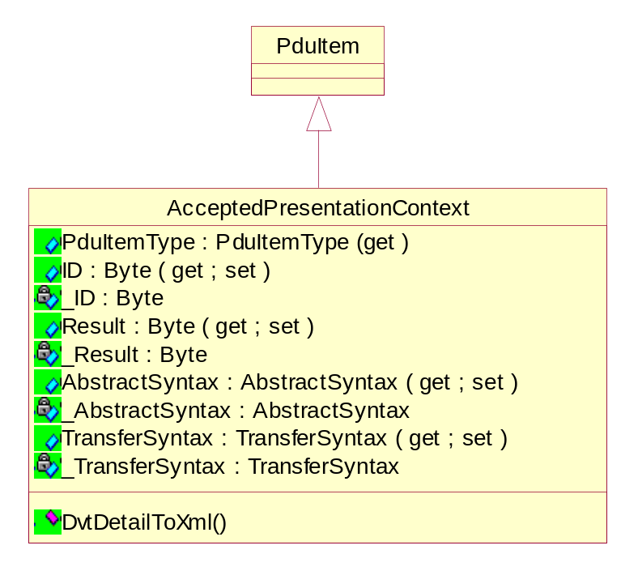
Figure 26 Class diagram of AcceptedPresentationContext

Properties of AcceptedPresentationContext class

Getting the PDU item type as AC_PRESENTATION_CONTEXT
public override PduItemType PduItemType(get;)

Getting the Accepted Presentation Context UID
public System.Byte ID(get; set;)

Getting the result
public System.Byte Result(get; set;)

Getting the abstract syntax
public AbstractSyntax AbstractSyntax(get; set;)

Getting the transfer syntax
public TransferSyntax TransferSyntax(get; set)

Methods of AcceptedPresentationContext class

Serialize DVT Detail Data to Xml
public bool DvtDetailToXml(StreamWriter streamWriter, int level);

Class Description of ApplicationContext
This class provides the Application Context. An application context explicitly defines the set of application service elements, related options and any other information necessary for the inter-working of Application Entities on an association.
Two Application Entities when establishing an association agree on an application context. The requestor of an association proposes an Application Context Name and the acceptor returns either the same or a different Application Context Name. The returned name specifies the application context to be used for this association. The offer of an alternate application context by the acceptor provides a mechanism for limited negotiation. If the requestor cannot operate in the acceptor's application context, it will issue an A-Abort request primitive. Such a negotiation will facilitate the introduction of future versions of the DICOM Application Entity.

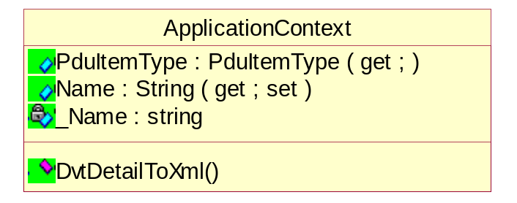
Figure 27 Class diagram of ApplicationContext

Properties of ApplicationContext class

Getting the PDU item type as APPLICATION_CONTEXT
public override PduItemType PduItemType(get;)

Getting the application context name
public string Name(get; set;)

Methods of ApplicationContext class

Serialize DVT Detail Data to Xml
public bool DvtDetailToXml(StreamWriter streamWriter, int level);

Class Description of DulMessage
This is the abstract class.
The DUL message consists of Protocol Data Units (PDUs) exchanged between peer entities within a layer. A PDU shall consist of protocol control information and user data. PDUs are constructed by mandatory fixed fields followed by optional variable fields, which contain one or more items and/or sub-items.
Items of unrecognized types shall be ignored and skipped. Items shall appear in an increasing order of their item types. Several instances of the same item shall be acceptable or shall not as specified by each item.
The DICOM UL protocol consists of seven Protocol Data Units:
a) A-ASSOCIATE-RQ PDU
b) A-ASSOCIATE-AC PDU
c) A-ASSOCIATE-RJ PDU
d) P-DATA-TF PDU
e) A-RELEASE-RQ PDU
f) A-RELEASE-RP PDU
g) A-ABORT PDU

Properties of DulMessage class

Getting the PDU type
public abstract PduType PduType(get;)

Methods of DulMessage class

Serialize DVT Detail Data to Xml
public abstract bool DvtDetailToXml(StreamWriter streamWriter, int level);

Class Description of A_ASSOCIATE_RQ
This class implements A_ASSOCIATE_RQ. The establishment of an association between two AEs shall be performed through ACSE A-ASSOCIATE request, indication, response and confirmation primitives.
The initiator of the service is hereafter called a requestor and the service-user, which receives the A-ASSOCIATE indication, is hereafter called the acceptor.
It shall be a confirmed service.

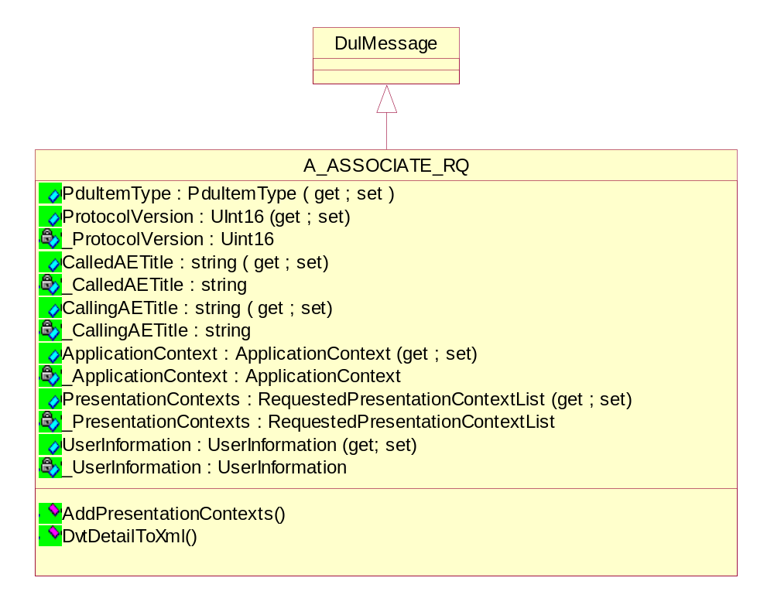
Figure 28 Class diagram of A_ASSOCIATE_RQ

Properties of A_ASSOCIATE_RQ class

Getting the PDU type as A_ASSOCIATE_RQ
public override PduType PduType(get;)

Getting/Setting the protocol version
public System.UInt16 ProtocolVersion(get; set;)

Getting/Setting the called AE title
public string CalledAETitle(get; set;)

Getting/Setting the calling AE title
public string CallingAETitle(get; set;)

Getting/Setting the application context name
public ApplicationContext ApplicationContext(get; set;)

Getting/Setting the presentation contexts
public RequestedPresentationContextList PresentationContexts(get; set;)

Getting/Setting the user information
public UserInformation UserInformation(get; set;)

Methods of A_ASSOCIATE_RQ class

Adding the list of requested presentation contexts
public void AddPresentationContexts (params RequestedPresentationContext[] presentationContexts);
public RequestedPresentationContext AddNewPresentationContext();

Serialize DVT Detail Data to Xml
public bool DvtDetailToXml(StreamWriter streamWriter, int level);

Class Description of A_ASSOCIATE_AC
This class implements A_ASSOCIATE_RQ. The establishment of an association between two AEs shall be performed through ACSE A-ASSOCIATE request, indication, response and confirmation primitives.
The initiator of the service is hereafter called a requestor and the service-user, which receives the A-ASSOCIATE indication, is hereafter called the acceptor.
It shall be a confirmed service.

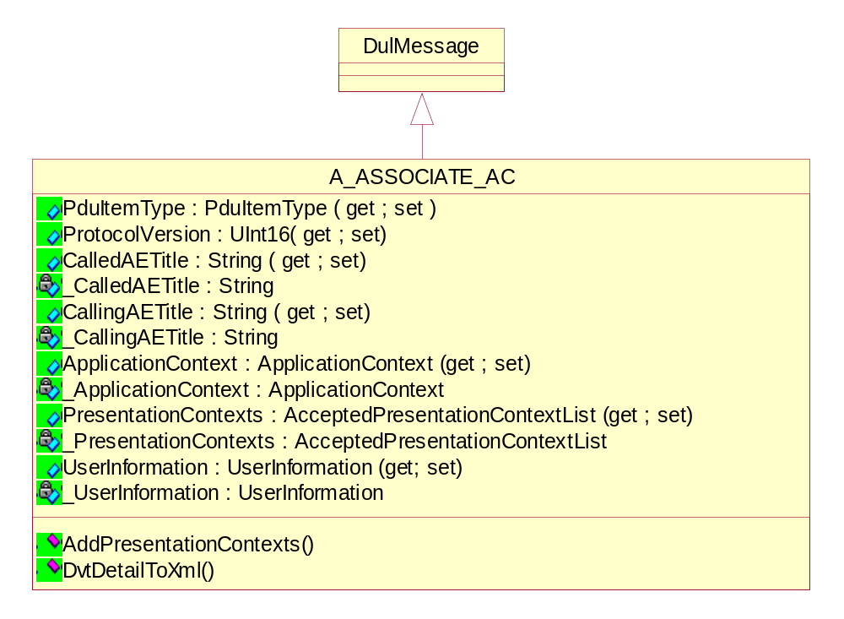
Figure 29 Class diagram of A_ASSOCIATE_AC

Properties of A_ASSOCIATE_AC class

Getting the PDU type as A_ASSOCIATE_AC
public override PduType PduType(get;)

Getting/Setting the protocol version
public System.UInt16 ProtocolVersion(get; set;)

Getting/Setting the called AE title
public string CalledAETitle(get; set;)

Getting/Setting the calling AE title
public string CallingAETitle(get; set;)

Getting/Setting the application context name
public ApplicationContext ApplicationContext(get; set;)

Getting/Setting the accepted list of presentation contexts
public AcceptedPresentationContextList PresentationContexts(get; set;)

Getting/Setting the user information
public UserInformation UserInformation(get; set;)

Methods of A_ASSOCIATE_AC class

Adding presentation context
public void AddPresentationContexts (params AcceptedPresentationContext [] presentationContexts);

Serialize DVT Detail Data to Xml
public bool DvtDetailToXml(StreamWriter streamWriter, int level);

Class Description of A_ASSOCIATE_RJ
This class implements A_ASSOCIATE_RJ.
The establishment of an association between two AEs shall be performed through ACSE A-ASSOCIATE request, indication, response and confirmation primitives.
The initiator of the service is hereafter called a requestor and the service-user, which receives the A-ASSOCIATE indication, is hereafter called the acceptor.
It shall be a confirmed service.
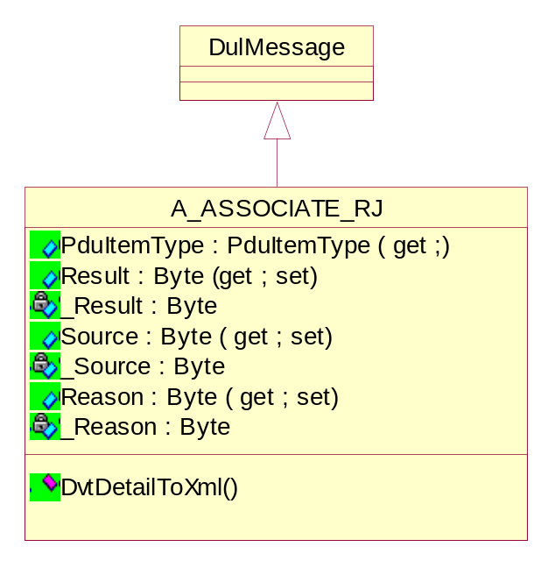
Figure 30 Class diagram of A_ASSOCIATE_RJ

Properties of A_ASSOCIATE_RJ class

Getting the PDU type as A_ASSOCIATE_RJ
public override PduType PduType(get;)

Getting/Setting the result parameter
public System.Byte Result(get; set;)

Getting/Setting the source parameter
public System.Byte Source(get; set;)

Getting/Setting the reason parameter
public System.Byte Reason(get; set;)

Methods of A_ASSOCIATE_RJ class

Serialize DVT Detail Data to Xml
public bool DvtDetailToXml(StreamWriter streamWriter, int level);

Class Description of A_ABORT
This class implements A_ABORT.
The ACSE A-ABORT service shall be used by a requestor in either of the AEs to cause the abnormal release of the association.
It shall be a non-confirmed service.
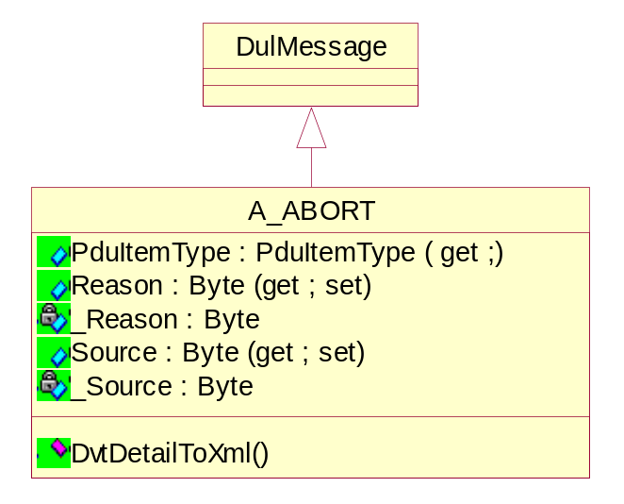
Figure 31 Class diagram of A_ABORT

Properties of A_ABORT class

Getting the PDU type as A_ABORT
public override PduType PduType(get;)

Getting/Setting the source parameter
public System.Byte Source(get; set;)

Getting/Setting the reason parameter
public System.Byte Reason(get; set;)

Methods of A_ABORT class

Serialize DVT Detail Data to Xml
public bool DvtDetailToXml(StreamWriter streamWriter, int level);

Class Description of A_RELEASE_RQ
This class implements A_RELEASE_RQ.
The graceful release of an association between two AEs shall be performed through ACSE A-RELEASE request, indication, response, and confirmation primitives.
The initiator of the service is hereafter called a requestor and the service-user, which receives the A-RELEASE indication, is hereafter called the acceptor.
It shall be a confirmed service.
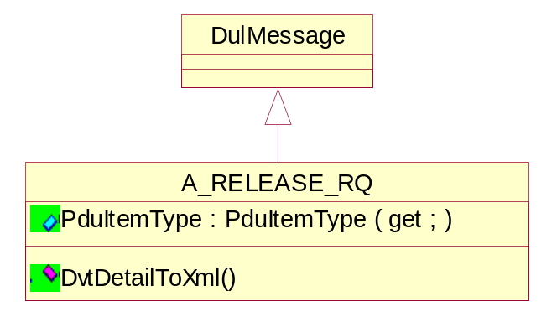
Figure 32 Class diagram of A_RELEASE_RQ

Properties of A_RELEASE_RQ class

Getting the PDU type as A_RELEASE_RQ
public override PduType PduType(get;)

Methods of A_RELEASE_RQ class

Serialize DVT Detail Data to Xml
public bool DvtDetailToXml(StreamWriter streamWriter, int level);

Class Description of A_RELEASE_RP
This class implements A_ RELEASE_RP.
The graceful release of an association between two AEs shall be performed through ACSE A-RELEASE request, indication, response, and confirmation primitives.
The initiator of the service is hereafter called a requestor and the service-user, which receives the A-RELEASE indication, is hereafter called the acceptor.
It shall be a confirmed service.

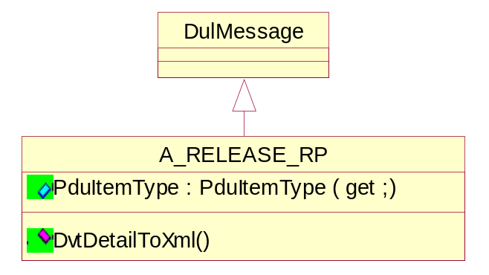
Figure 33 Class diagram of A_RELEASE_RP

Properties of A_RELEASE_RP class

Getting the PDU type as A_RELEASE_RP
public override PduType PduType(get;)

Methods of A_RELEASE_RP class

Serialize DVT Detail Data to Xml
public bool DvtDetailToXml(StreamWriter streamWriter, int level);

Class Description of P_DATA_TF
This Presentation P-DATA Service shall be used by either AE to cause the exchange of application information (i.e. DICOM Messages).
An association provides a simultaneous bi-directional exchange of P-DATA request/indication primitives.

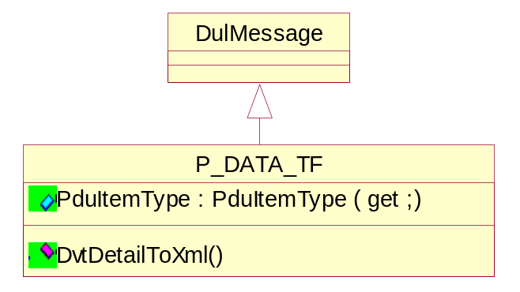
Figure 34 Class diagram of P_DATA_TF

Properties of P_DATA_TF class

Getting the PDU type as P_DATA_TF
public override PduType PduType(get;)

Methods of P_DATA_TF class

Serialize DVT Detail Data to Xml
public bool DvtDetailToXml(StreamWriter streamWriter, int level);

Detail design of DUL Validation Data classes

Class Description of ValidationAcseParameter
This class provides validation information about ACSE related parameter.

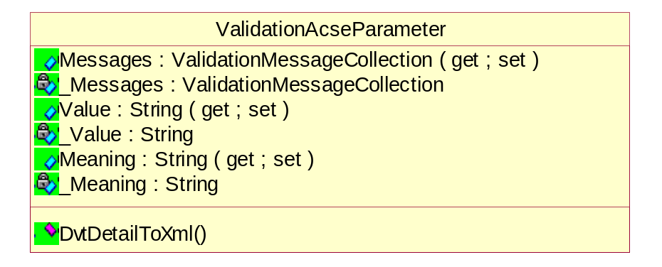
Figure 35 Class diagram of ValidationAcseParameter

Properties of ValidationAcseParameter class

Getting/Setting the validation massages
public ValidationMessageCollection Messages(get; set;)

Getting/Setting the value information about ACSE parameter
public string Value(get; set;)

Getting/Setting the meaning information about ACSE parameter
public string Meaning(get; set;)

Methods of ValidationAcseParameter class

Serialize DVT Detail Data to Xml
public bool DvtDetailToXml(StreamWriter streamWriter, int level);

Class Description of ValidationAbortRq
This class provides validation information about A_ABORT_RQ.

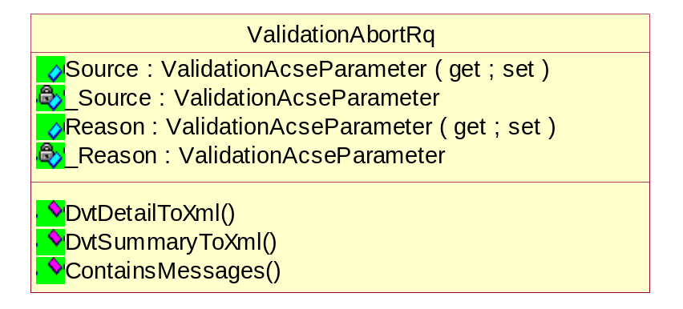
Figure 36 Class diagram of ValidationAbortRq

Properties of ValidationAbortRq class

Getting/Setting the validation information about source parameter
public ValidationAcseParameter Source(get; set;)

Getting/Setting the validation information about reason parameter
public ValidationAcseParameter Reason(get; set;)

Methods of ValidationAbortRq class

Checking if this contains any validation messages
private bool ContainsMessages();

Serialize DVT Detail Data to Xml
public bool DvtDetailToXml(StreamWriter streamWriter, int level);

Serialize DVT Summary Data to Xml
public bool DvtSummaryToXml(StreamWriter streamWriter, int level);

Class Description of ValidationAssociateRq
This class provides validation information about A_ASSOCIATE_RQ.

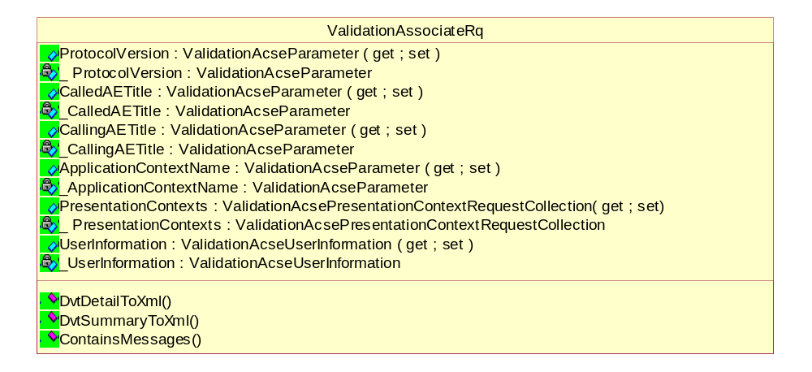
Figure 37 Class diagram of ValidationAssociateRq

Properties of ValidationAssociateRq class

Getting/Setting the validation information about protocol version
public ValidationAcseParameter ProtocolVersion(get; set;)

Getting/Setting the validation information about called AE title
public ValidationAcseParameter CalledAETitle(get; set;)

Getting/Setting the validation information about calling AE title
public ValidationAcseParameter CallingAETitle(get; set;)

Getting/Setting the validation information about application context name
public ValidationAcseParameter ApplicationContextName(get; set;)

Getting/Setting the validation information about presentation contexts
public ValidationAcsePresentationContextRequestCollection PresentationContexts(get; set;)

Getting/Setting the validation information about user information
public ValidationAcseUserInformation UserInformation(get; set;)

Methods of ValidationAssociateRq class

Checking if this contains any validation messages
private bool ContainsMessages();

Serialize DVT Detail Data to Xml
public bool DvtDetailToXml(StreamWriter streamWriter, int level);

Serialize DVT Summary Data to Xml
public bool DvtSummaryToXml(StreamWriter streamWriter, int level);

Class Description of ValidationAcsePresentationContextRequest
This class provides validation information about requested presentation contexts.

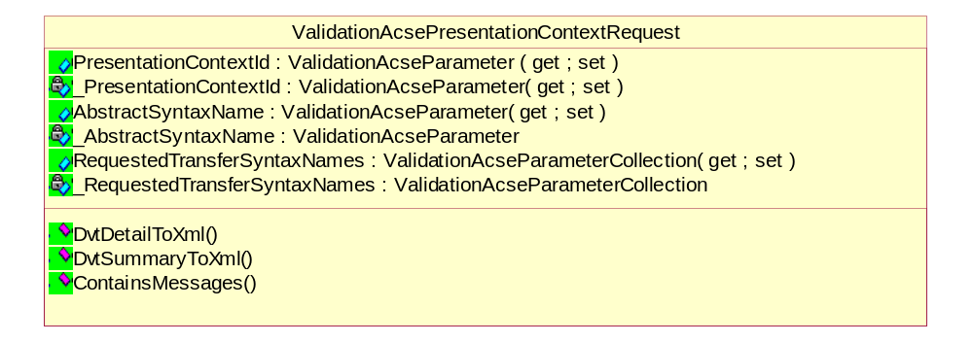
Figure 38 Class diagram of ValidationAcsePresentationContextRequest

Properties of ValidationAcsePresentationContextRequest class

Getting/Setting the validation information about presentation context ID
public ValidationAcseParameter PresentationContextId(get; set;)

Getting/Setting the validation information about abstract syntax name
public ValidationAcseParameter AbstractSyntaxName(get; set;)

Getting/Setting the validation information about requested transfer syntaxes
public ValidationAcseParameterCollection RequestedTransferSyntaxNames(get; set;)

Methods of ValidationAcsePresentationContextRequest class

Checking if this contains any validation messages
private bool ContainsMessages();

Serialize DVT Detail Data to Xml
public bool DvtDetailToXml(StreamWriter streamWriter, int level);

Serialize DVT Summary Data to Xml
public bool DvtSummaryToXml(StreamWriter streamWriter, int level);

Class Description of ValidationAcseUserInformation
This class provides validation information about user information.

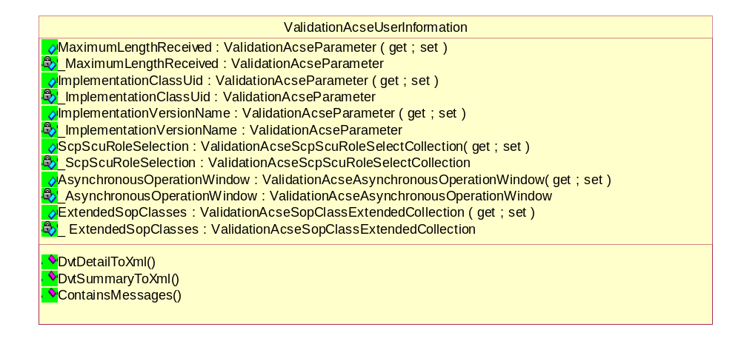
Figure 39 Class diagram of ValidationAcseUserInformation

Properties of ValidationAcseUserInformation class

Getting/Setting the validation information about maximum length
public ValidationAcseParameter MaximumLengthReceived(get; set;)

Getting/Setting the validation information about implementation class UID
public ValidationAcseParameter ImplementationClassUid(get; set;)

Getting/Setting the validation information about implementation version name
public ValidationAcseParameter ImplementationVersionName(get; set;)

Getting/Setting the validation information about SCP/SCU role selection
public ValidationAcseScpScuRoleSelectCollection ScpScuRoleSelection(get; set;)

Getting/Setting the validation information about Async operation window
public ValidationAcseAsynchronousOperationWindow AsynchronousOperationWindow(get; set;)

Getting/Setting the validation information about extended Sop class
public ValidationAcseSopClassExtendedCollection ExtendedSopClasses(get; set;)

Methods of ValidationAcseUserInformation class

Checking if this contains any validation messages
private bool ContainsMessages();

Serialize DVT Detail Data to Xml
public bool DvtDetailToXml(StreamWriter streamWriter, int level);

Serialize DVT Summary Data to Xml
public bool DvtSummaryToXml(StreamWriter streamWriter, int level);

Class Description of ValidationAcseScpScuRoleSelect
This class provides validation information about SCP/SCU role select parameter.

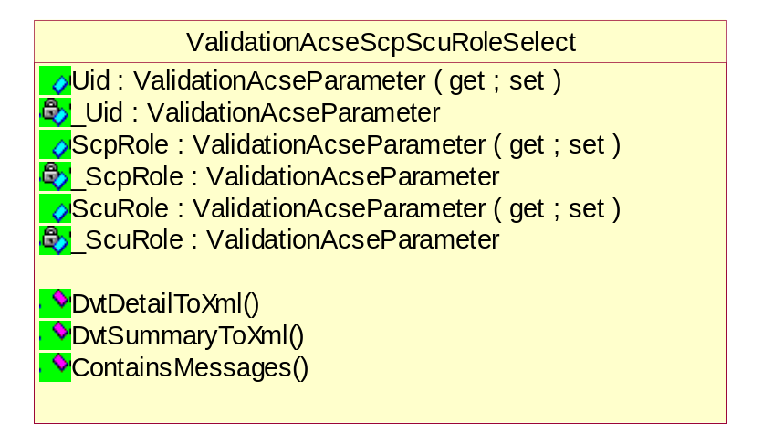
Figure 40 Class diagram of ValidationAcseScpScuRoleSelect

Properties of ValidationAcseScpScuRoleSelect class

Getting/Setting the validation information about UID
public ValidationAcseParameter Uid(get; set;)

Getting/Setting the validation information about SCU role
public ValidationAcseParameter ScpRole(get; set;)

Getting/Setting the validation information about SCP role
public ValidationAcseParameter ScuRole(get; set;)

Methods of ValidationAcseScpScuRoleSelect class

Checking if this contains any validation messages
private bool ContainsMessages();

Serialize DVT Detail Data to Xml
public bool DvtDetailToXml(StreamWriter streamWriter, int level);

Serialize DVT Summary Data to Xml
public bool DvtSummaryToXml(StreamWriter streamWriter, int level);

Class Description of ValidationAcseAsynchronousOperationWindow
This class provides validation information about asynchronous operation window parameter.

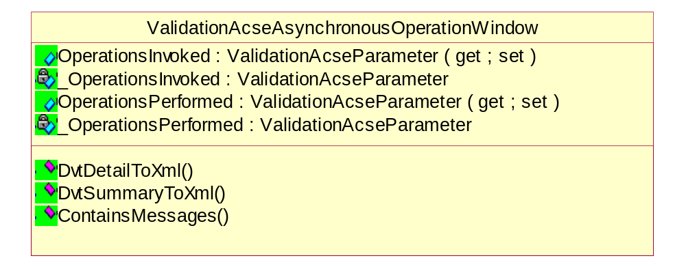
Figure 41 Class diagram of ValidationAcseAsynchronousOperationWindow

Properties of ValidationAcseAsynchronousOperationWindow class

Getting/Setting the validation information about operations invoked
public ValidationAcseParameter OperationsInvoked(get; set;)

Getting/Setting the validation information about operations performed
public ValidationAcseParameter OperationsPerformed(get; set;)

Methods of ValidationAcseAsynchronousOperationWindow class

Checking if this contains any validation messages
private bool ContainsMessages();

Serialize DVT Detail Data to Xml
public bool DvtDetailToXml(StreamWriter streamWriter, int level);

Serialize DVT Summary Data to Xml
public bool DvtSummaryToXml(StreamWriter streamWriter, int level);

Class Description of ValidationAcseSopClassExtended
This class provides validation information about SOP Class extended parameter.

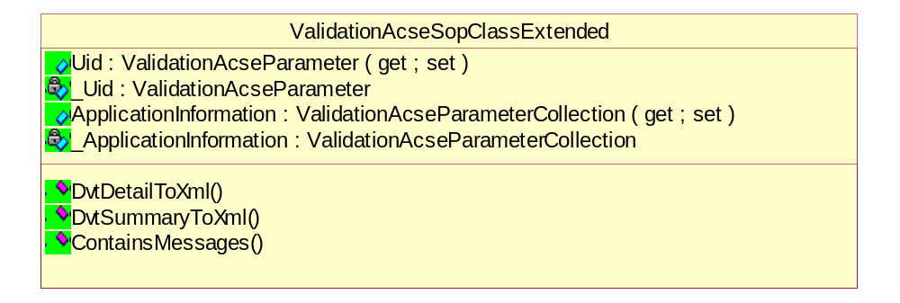
Figure 42 Class diagram of ValidationAcseSopClassExtended

Properties of ValidationAcseSopClassExtended class

Getting/Setting the validation information about SOP class UID
public ValidationAcseParameter Uid(get; set;)

Getting/Setting the validation information about application information
ValidationAcseParameterCollection ApplicationInformation(get; set;)

Methods of ValidationAcseSopClassExtended class

Checking if this contains any validation messages
private bool ContainsMessages();

Serialize DVT Detail Data to Xml
public bool DvtDetailToXml(StreamWriter streamWriter, int level);

Serialize DVT Summary Data to Xml
public bool DvtSummaryToXml(StreamWriter streamWriter, int level);

Class Description of ValidationAssociateAc
This class provides validation information about A_ASSOCIATE_AC.

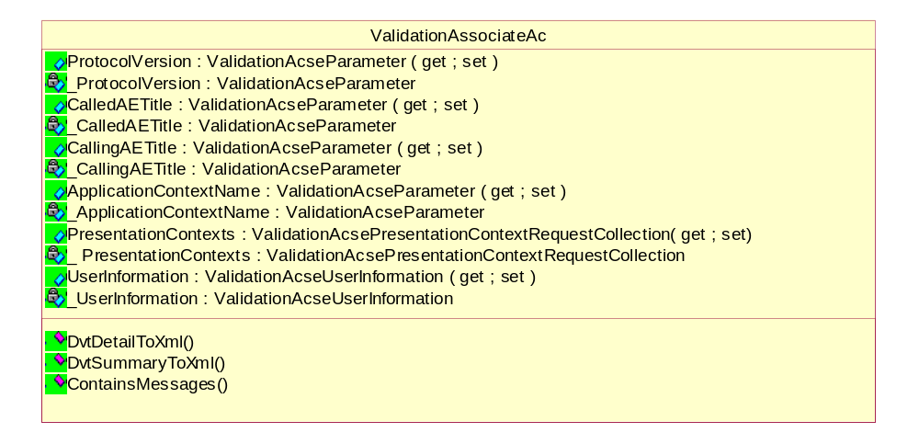
Figure 43 Class diagram of ValidationAssociateAc

Properties of ValidationAssociateAc class

Getting/Setting the validation information about protocol version
public ValidationAcseParameter ProtocolVersion(get; set;)

Getting/Setting the validation information about called AE title
public ValidationAcseParameter CalledAETitle(get; set;)

Getting/Setting the validation information about calling AE title
public ValidationAcseParameter CallingAETitle(get; set;)

Getting/Setting the validation information about application context name
public ValidationAcseParameter ApplicationContextName(get; set;)

Getting/Setting the validation information about presentation contexts
public ValidationAcsePresentationContextAcceptCollection PresentationContexts(get; set;)

Getting/Setting the validation information about user information
public ValidationAcseUserInformation UserInformation(get; set;)

Methods of ValidationAssociateAc class

Checking if this contains any validation messages
private bool ContainsMessages();

Serialize DVT Detail Data to Xml
public bool DvtDetailToXml(StreamWriter streamWriter, int level);

Serialize DVT Summary Data to Xml
public bool DvtSummaryToXml(StreamWriter streamWriter, int level);

Class Description of ValidationAcsePresentationContextAccept
This class provides validation information about accepted presentation contexts.

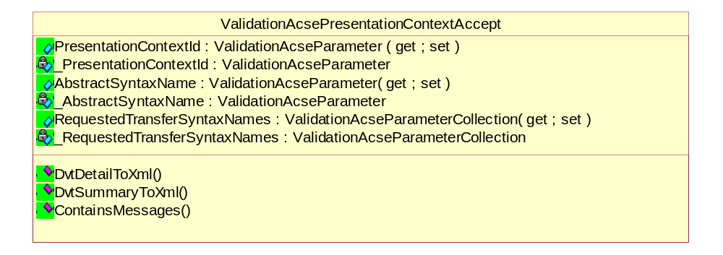
Figure 44 Class diagram of ValidationAcsePresentationContextAccept

Properties of ValidationAcsePresentationContextAccept class

Getting/Setting the validation information about presentation context ID
public ValidationAcseParameter PresentationContextId(get; set;)

Getting/Setting the validation information about abstract syntax name
public ValidationAcseParameter AbstractSyntaxName(get; set;)

Getting/Setting the validation information about result
public ValidationAcseParameter Result(get; set;)

Getting/Setting the validation information about transfer syntax name
public ValidationAcseParameter TransferSyntaxName(get; set;)

Methods of ValidationAcsePresentationContextAccept class

Checking if this contains any validation messages
private bool ContainsMessages();

Serialize DVT Detail Data to Xml
public bool DvtDetailToXml(StreamWriter streamWriter, int level);

Serialize DVT Summary Data to Xml
public bool DvtSummaryToXml(StreamWriter streamWriter, int level);

Class Description of ValidationAssociateRj
This class provides validation information about A_ASSOCIATE_RJ.

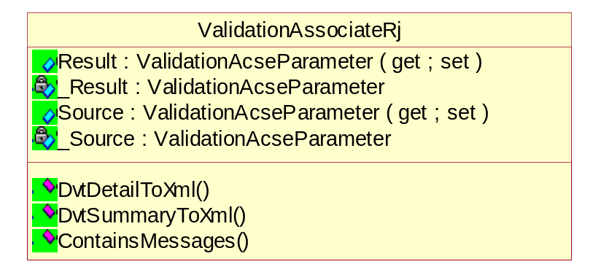
Figure 45 Class diagram of ValidationAssociateRj

Properties of ValidationAssociateRj class

Getting/Setting the validation information about result parameter
public ValidationAcseParameter Result(get; set;)

Getting/Setting the validation information about source parameter
public ValidationAcseParameter Source(get; set;)

Getting/Setting the validation information about reason parameter
public ValidationAcseParameter Reason(get; set;)

Methods of ValidationAssociateRj class

Checking if this contains any validation messages
private bool ContainsMessages();

Serialize DVT Detail Data to Xml
public bool DvtDetailToXml(StreamWriter streamWriter, int level);

Serialize DVT Summary Data to Xml
public bool DvtSummaryToXml(StreamWriter streamWriter, int level);

Class Description of ValidationReleaseRq
This class provides validation information about A_RELEASE_RQ.

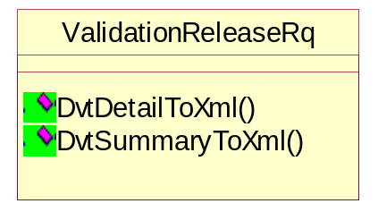
Figure 46 Class diagram of ValidationReleaseRq

Methods of ValidationReleaseRq class

Serialize DVT Detail Data to Xml
public bool DvtDetailToXml(StreamWriter streamWriter, int level);

Serialize DVT Summary Data to Xml
public bool DvtSummaryToXml(StreamWriter streamWriter, int level);

Class Description of ValidationReleaseRp
This class provides validation information about A_ RELEASE_RP.

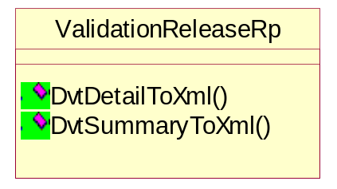
Figure 47 Class diagram of ValidationReleaseRp

Methods of ValidationReleaseRp class

Serialize DVT Detail Data to Xml
public bool DvtDetailToXml(StreamWriter streamWriter, int level);

Serialize DVT Summary Data to Xml
public bool DvtSummaryToXml(StreamWriter streamWriter, int level);

Detail design of Media Data classes

Class Description of DicomFile
A DICOM File is a File with a content formatted according to the requirements of Part 10 of the DICOM Standard. In particular such files shall contain, the File Meta Information and a properly formatted Data Set.

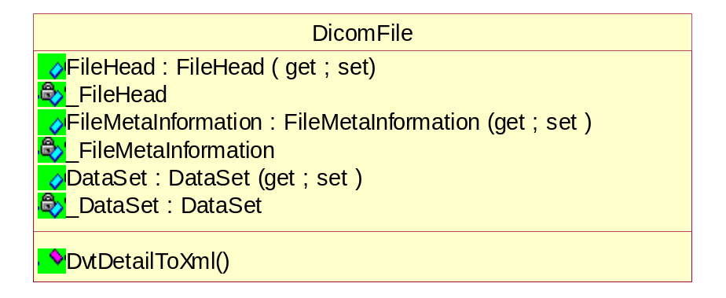
Figure 48 Class diagram of DicomFile

Properties of DicomFile class

Getting/Setting the validation information about DICOM file header
public FileHead FileHead(get; set;)

Getting/Setting the validation information about FMI
public FileMetaInformation FileMetaInformation(get; set;)
The File Meta Information includes identifying information on the encapsulated Data Set. It is a mandatory header at the beginning of every DICOM File.
In the DICOM standard, this FileHead is actually part of the File Meta Information.

Getting/Setting the validation information about dataset
public DataSet DataSet(get; set;)
Each File shall contain a single Data Set representing a single SOP Instance related to a single SOP Class (and corresponding IOD).
The Transfer Syntax used to encode the Data Set shall be the one identified by the Transfer Syntax UID of the DICOM File Meta Information.
The last Data Element of a Data Set may be Data Element (FFFC,FFFC) if padding of a Data Set is desired when a file is written. The Value of this Data Set Trailing Padding Data Element (FFFC,FFFC)has no significance and shall be ignored by all DICOM implementations reading this Data Set.
File-set Readers or Updaters shall be able to process this Data Set Trailing Padding (FFFC,FFFC) either in the Data Set following the Meta Information or in Data Sets nested in a Sequence (See PS 3.5 of the DICOM Standard).

Methods of DicomFile class

Serialize DVT Detail Data to Xml
public bool DvtDetailToXml(StreamWriter streamWriter, int level);

Class Description of FileHead
This class represents the File Head, which contains the File Preamble, DICOM Prefix and Transfer Syntax UID.
In the DICOM standard, this FileHead is actually part of the File Meta Information.

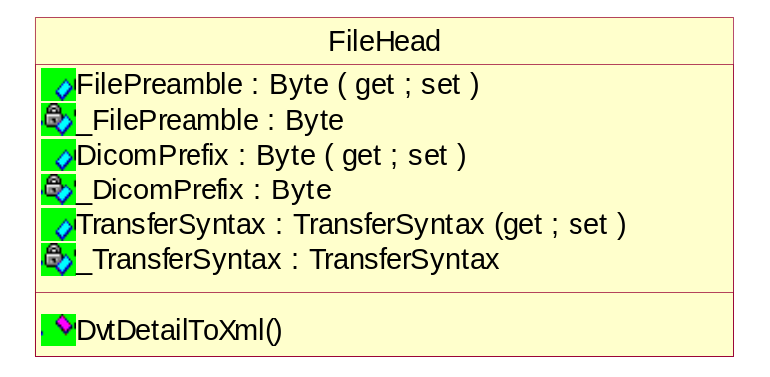
Figure 49 Class diagram of FileHead

Properties of FileHead class

Getting/Setting the file preamble
public System.Byte[] FilePreamble(get; set;)
A fixed 128-byte field available for Application Profile or implementation specified use. If not used by an Application Profile or a specific implementation all bytes shall be set to 00H.

Getting/Setting the DICOM prefix
public System.Byte[] DicomPrefix(get; set;)
Four bytes containing the character string "DICM".
This prefix is intended to be used to recognize that this File is or is not a DICOM File.

Getting/Setting the transfer syntax
public DvtkData.Dul.TransferSyntax TransferSyntax(get; set;)
Uniquely identifies the Transfer Syntax used to encode the following Data Set. This Transfer Syntax does not apply to the File Meta Information.

Methods of FileHead class

Serialize DVT Detail Data to Xml
public bool DvtDetailToXml(StreamWriter streamWriter, int level);

Detail design of Result classes

Class Description of Result
This class is the top-level element of the Dvtk output. It is the container for the various results nodes and also forms the top-level Xml-element in the Xml output.

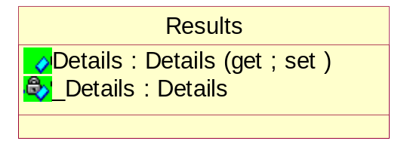
Figure 50 Class diagram of Result

Properties of Result class

Getting/Setting the first node in the result
public Details Details(get; set;)

Class Description of SubResultsLink
This class references to another results document.
It is used in parent-child relationship for results documents.
For emulators, the results of individual associations are outputted to separate child results documents.

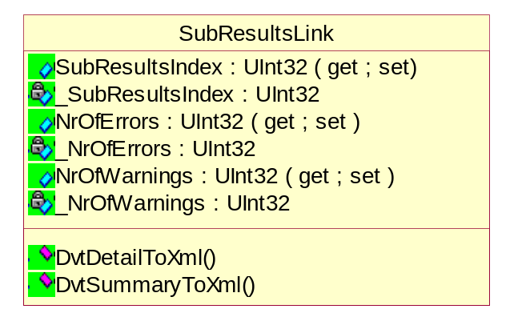
Figure 51 Class diagram of SubResultsLink

Properties of SubResultsLink class

Getting/Setting the reference to a child results document
public System.UInt32 SubResultsIndex(get; set;)

Getting/Setting the nr of errors
public System.UInt32 NrOfErrors(get; set;)

Getting/Setting the nr of warnings
public System.UInt32 NrOfWarnings(get; set;)

Methods of SubResultsLink class

Serialize DVT Detail Data to Xml
public bool DvtDetailToXml(StreamWriter streamWriter, int level);

Serialize DVT Summary Data to Xml
public bool DvtSummaryToXml(StreamWriter streamWriter, int level);

Class Description of Detail
This class represents first node in the results. Specifies details over the session.

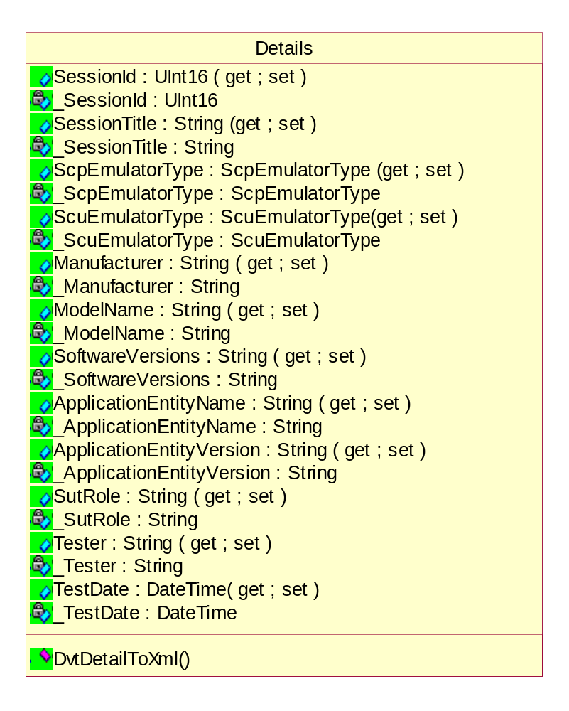
Figure 52 Class diagram of Detail

Properties of Detail class

Getting/Setting the session identifier
public System.UInt16 SessionId(get; set;)

Getting/Setting the session title
public string SessionTitle(get; set;)

Getting/Setting the SCP emulator type
public ScpEmulatorType ScpEmulatorType(get; set;)

Getting/Setting the SCU emulator type
public ScuEmulatorType ScuEmulatorType(get; set;)

Getting/Setting the manufacturer
public string Manufacturer(get; set;)

Getting/Setting the SUT model name
public string ModelName(get; set;)

Getting/Setting the software version of SUT
public string SoftwareVersions(get; set;)

Getting/Setting the application entity name of SUT
public string ApplicationEntityName(get; set;)

Getting/Setting the application entity version of SUT
public string ApplicationEntityVersion(get; set;)

Getting/Setting the SUT role
public string SutRole(get; set;)

Getting/Setting the tester name
public string Tester(get; set;)

Getting/Setting the test date
public System.DateTime TestDate(get; set;)

Methods of Detail class

Serialize DVT Detail Data to Xml
public bool DvtDetailToXml(StreamWriter streamWriter, int level);

Class Description of Counters
This class represents counters to maintain count of messages at various severity levels.

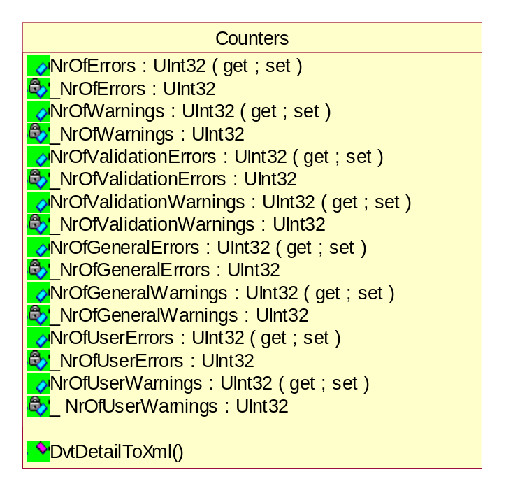
Figure 53 Class diagram of Counters

Properties of Counters class

Getting/Setting the nr of errors
public System.UInt32 NrOfErrors(get;)

Getting/Setting the nr of warnings
public System.UInt32 NrOfWarnings(get;)

Getting/Setting the the nr of validation errors
public System.UInt32 NrOfValidationErrors(get; set;)

Getting/Setting the nr of validation warnings
public System.UInt32 NrOfValidationWarnings(get; set;)

Getting/Setting the the nr of general errors
public System.UInt32 NrOfGeneralErrors(get; set;)

Getting/Setting the nr of general warnings
public System.UInt32 NrOfGeneralWarnings(get; set;)

Getting/Setting the the nr of user errors
public System.UInt32 NrOfUserErrors(get; set;)

Getting/Setting the nr of user warnings
public System.UInt32 NrOfUserWarnings(get; set;)

Methods of Counters class

Serialize DVT Detail Data to Xml
public bool DvtDetailToXml(StreamWriter streamWriter, int level);

Class Description of Send
This class represents results node for a performed send action.

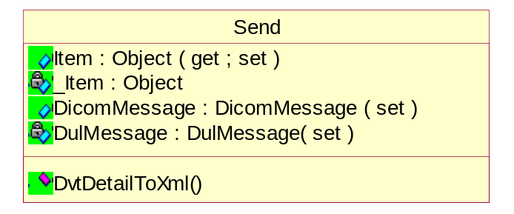
Figure 54 Class diagram of Send

Properties of Send class

Getting/Setting the item to set
public object Item(get; set;)

Getting/Setting the DICOM message
public DicomMessage DicomMessage(set;)

Getting/Setting the DUL message
public DulMessage DulMessage(set;)

Methods of Send class

Serialize DVT Detail Data to Xml
public bool DvtDetailToXml(StreamWriter streamWriter, int level);

Class Description of Receive
This class represents results node for a performed receive action.

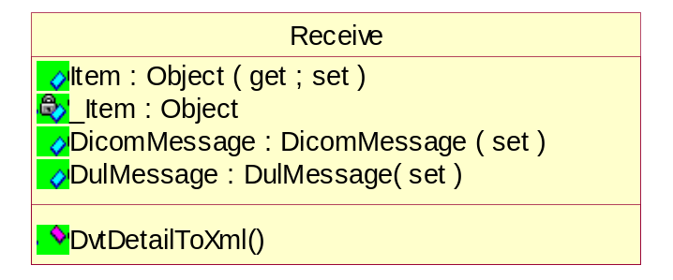
Figure 55 Class diagram of Receive

Properties of Receive class

Getting/Setting the item to set
public object Item(get; set;)

Getting/Setting the DICOM message
public DicomMessage DicomMessage(set;)

Getting/Setting the DUL message
public DulMessage DulMessage(set;)

Methods of Receive class

Serialize DVT Detail Data to Xml
public bool DvtDetailToXml(StreamWriter streamWriter, int level);

Class Description of Import
This class represents results node for a performed import action.

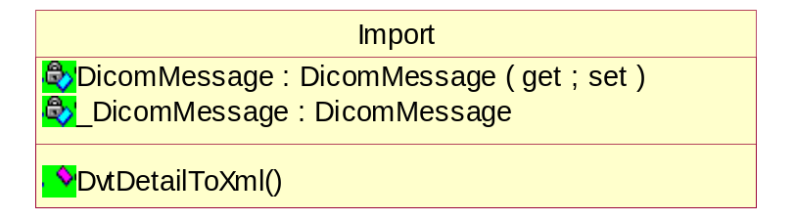
Figure 56 Class diagram of Import

Properties of Import class

Getting/Setting the DICOM message
public DicomMessage DicomMessage(set;)

Methods of Import class

Serialize DVT Detail Data to Xml
public bool DvtDetailToXml(StreamWriter streamWriter, int level);

Class Description of Display
This class represents results node for a performed display action.

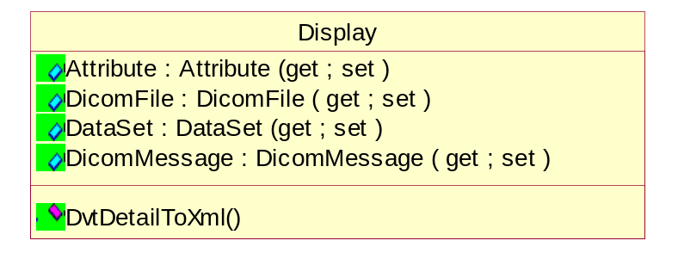
Figure 57 Class diagram of Display

Properties of Display class

Getting/Setting the nr of general warnings
public Attribute Attribute(get; set;)

Getting/Setting the the nr of user errors
public DicomFile DicomFile(get; set;)

Getting/Setting the DICOM message
public DicomMessage DicomMessage(get; set;)

Getting/Setting the nr of user warnings
public DataSet DataSet(get; set;)

Methods of Display class

Serialize DVT Detail Data to Xml
public bool DvtDetailToXml(StreamWriter streamWriter, int level);

Class Description of MediaWrite
This class represents results node for a performed media write action.

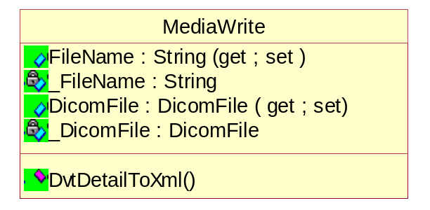
Figure 58 Class diagram of MediaWrite

Properties of MediaWrite class

Getting/Setting the file name
public string FileName(get; set;)

Getting/Setting the contents of DICOM file
public DicomFile DicomFile(get; set;)

Methods of MediaWrite class

Serialize DVT Detail Data to Xml
public bool DvtDetailToXml(StreamWriter streamWriter, int level);

Class Description of MediaRead
This class represents results node for a performed media read action.

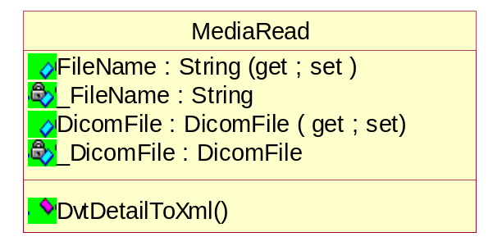
Figure 59 Class diagram of MediaRead

Properties of MediaRead class

Getting/Setting the file name
public string FileName(get; set;)

Getting/Setting the contents of DICOM file
public DicomFile DicomFile(get; set;)

Methods of MediaRead class

Serialize DVT Detail Data to Xml
public bool DvtDetailToXml(StreamWriter streamWriter, int level);

Class Description of DicomScriptCreate
This class represents Xml node for a Dicom Script (.DS) script CREATE command.

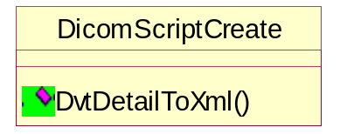
Figure 60 Class diagram of DicomScriptCreate

Methods of DicomScriptCreate class

Serialize DVT Detail Data to Xml
public bool DvtDetailToXml(StreamWriter streamWriter, int level);

Class Description of DicomScriptSet
This class represents Xml node for a Dicom Script (.DS) script SET command.

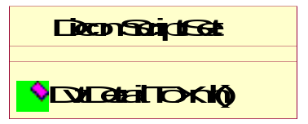
Figure 61 Class diagram of DicomScriptSet

Methods of DicomScriptSet class

Serialize DVT Detail Data to Xml
public bool DvtDetailToXml(StreamWriter streamWriter, int level);

Class Description of DicomScriptDelete
This class represents Xml node for a Dicom Script (.DS) script DELETE command.

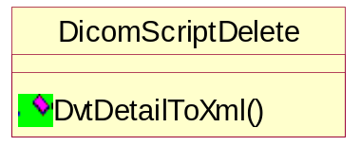
Figure 62 Class diagram of DicomScriptDelete

Methods of DicomScriptDelete class

Serialize DVT Detail Data to Xml
public bool DvtDetailToXml(StreamWriter streamWriter, int level);

Class Description of DicomScriptCreateSetDeleteActionBase
This class is the abstract base class for Xml node for a DICOM Script (.DS) script CREATE/SET/DELETE commands.

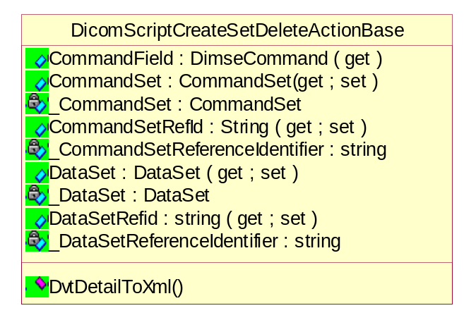
Figure 63 Class diagram of DicomScriptCreateSetDeleteActionBase

Properties of DicomScriptCreateSetDeleteActionBase class

Getting/Setting the command field
public DimseCommand CommandField(get;)

Getting/Setting the command set
public CommandSet CommandSet(get; set;)

Getting/Setting the Reference Identifier for the command set in the data warehouse
public System.String CommandSetRefId(get; set;)

Getting/Setting the data set
public DataSet DataSet(get; set;)

Getting/Setting the Reference Identifier for the data set in the data warehouse
public System.String DataSetRefId(get; set;)

Methods of DicomScriptCreateSetDeleteActionBase class

Serialize DVT Detail Data to Xml
public bool DvtDetailToXml(StreamWriter streamWriter, int level);

Class Description of ByteDump
This class displays a byte dump of DVT socket communication.
This byte dump information may be used to debug communication problems.

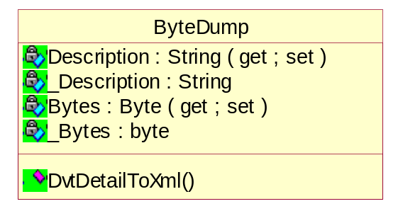
Figure 64 Class diagram of ByteDump

Properties of ByteDump class

Getting/Setting the literal description for the byte dump
public System.String Description(get; set;))

Getting/Setting the bytes dumped
public System.Byte[] Bytes(get; set;)

Methods of ByteDump class

Serialize DVT Detail Data to Xml
public bool DvtDetailToXml(StreamWriter streamWriter, int level);

Class Description of DvtToXml
This class provides static conversion methods for XML output.

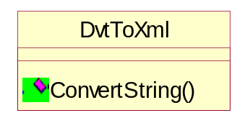
Figure 65 Class diagram of DvtToXml

Methods of DvtToXml class

Converting the incoming string into an XML format by replacing some characters by their XML coding
public static System.String ConvertString(System.String inString);

